**Carbohydrates**

Prior knowledge:

1. What is the relationship between monomers and polymers?

..........................................................................................................................

..........................................................................................................................

1. What type of reaction joins monomers?..........................................................
2. What type of reaction breaks down polymers? ..............................................

Carbohydrates contain only three elements:- ...........................................................

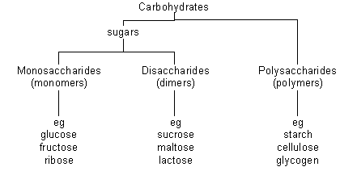

Monosaccharides

* These are the monomers from which all other carbohydrates are built.
* They are soluble and sweet
* They can move through cell membranes
* They take part in many reactions in cells
* Glucose and fructose are reducing sugars:-

Reaction with Benedict’s

Glucose - formula is C6H12O6

There are two forms of glucose - α and β

They have the same atoms but they are arranged differently – they are ...........................................

|  |  |
| --- | --- |
| Structure of α glucose | Structure of β glucose |
|  |  |

Disaccharides

Disaccharides are formed when two monosaccharides are joined.

The reaction is a …………………………………………………… reaction.

The bond formed is called a glycosidic bond.

Maltose is made from two molecules of α glucose.

* It is a reducing sugar
* It is the first breakdown product of starch in animal digestion and germinating seeds
* It is produced by germinating barley and is important in brewing beer

Draw the formation of maltose in this box:

|  |
| --- |
|  |

Sucrose is made from one molecule of α glucose and one molecule of fructose.

* It is a non-reducing sugar – test…
* Sucrose is the sugar that is transported in the phloem
* It is also used for storage in some plants e.g. sugar cane, sugar beet.

Lactose (or milk sugar) is made from one molecule of glucose and one molecule of galactose.

* It is found only in mammalian milk, and is the main source of energy for infant mammals.

Polysaccharides

These are …

Joined by…

They are large, not sweet, and insoluble

Starch

* Polymer of α glucose molecules
* Energy store in plants
* Insoluble

Test for starch

For starch, glycogen and cellulose see separate sheets.

|  |
| --- |
| Further reading and questions:  Extension box p.9 semi-quantitative Benedict’s  See chapters 1.2 – 1.4 and try summary questions. |