Lipids
Prior knowledge –
- What are lipids?.........................................................
- How are they broken down?........................................
- What are they broken down into?............................................................................
Lipids are a mixed group of hydrophobic compounds composed of the elements
................................... ...................................... .........................................
They contain fats and oils (fats are solid at room temperature, whereas oils are liquid)
Triglycerides
Triglycerides are commonly called fats or oils. They are made of ......................................... and ...................................................
Glycerol is a small, 3-carbon molecule with three hydroxyl groups.
Fatty acids are long molecules with a polar, hydrophilic end and a non-polar, hydrophobic "tail". The hydrocarbon chain can be from 14 to 22 CH₂ units long. The hydrocarbon chain is sometimes called an R group, so the formula of a fatty acid can be written as R-COOH.

Hydrophilic

.............................................................................

Hydrophobic

...............................................................................
- If there are no C=C double bonds in the hydrocarbon chain, then it is a saturated fatty acid (i.e. saturated with hydrogen). These fatty acids form straight chains, and have a high melting point.
- If there are C=C double bonds in the hydrocarbon chain, then it is an unsaturated fatty acid (i.e. unsaturated with hydrogen). These fatty acids form bent chains, and have a low melting point. Fatty acids with more than one double bond are called poly-unsaturated fatty acids (PUFAs).
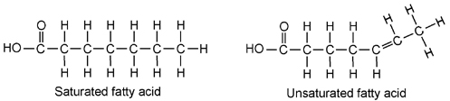
One molecule of glycerol joins togther with three fatty acid molecules to form a triglyceride molecule, in another .................................................. polymerisation reaction:
Triglycerides are ............................................... in water. They are used for storage, insulation and protection in fatty tissue found under the skin or surrounding organs.
They yield more energy per unit mass than other compounds so are good for energy storage.
- Triglycerides containing saturated fatty acids have a high melting point and tend to be found in warm-blooded animals. At room temperature they are solids (fats), e.g. butter, lard.
- Triglycerides containing unsaturated fatty acids have a low melting point and tend to be found in cold-blooded animals and plants. At room temperature they are liquids (oils), e.g. fish oil, vegetable oils.
Test for lipids

Phospholipids
Phospholipids have a similar structure to triglycerides, but with a phosphate group in place of one fatty acid chain.
Phospholipids have a polar hydrophilic "head" (the negatively-charged phosphate group) and two non-polar hydrophobic "tails" (the fatty acid chains).
- When mixed with water, phospholipids form droplet spheres with the hydrophilic heads facing the water and the hydrophobic tails facing each other. This is called a micelle. | 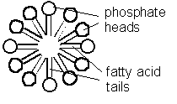
- Alternatively, they may form a double-layered phospholipid bilayer. This traps a compartment of water in the middle separated from the external water by the hydrophobic sphere. This naturally-occurring structure is called a liposome, and is similar to a membrane surrounding a cell. | 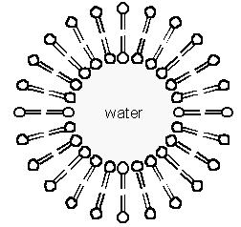

Further reading and questions
See textbook section 1.5 including summary questions page 18

