**Proteins**

Prior knowledge

1. Proteins are made from ……………… ……………….
2. They contain the elements …………….. ………………… ……………….
3. They are broken down by …………………………………
4. Proteins in the body include - ……………………….. ………………………….

……………………………. ……………………………

Basic principles

Monomer………………………………………………………………………………………

Polymer…………………………………………………………………………………………

Condensation reaction

..........................................................................................................................

Hydrolysis reaction

..........................................................................................................................

Structure of an amino acid:-

Polypeptides

When two amino acids join - the reaction is……

The bond is called a peptide bond.

Draw two amino acids in this box:

|  |
| --- |
|  |

Now show how they are joined to form a dipeptide in this box:

|  |
| --- |
|  |

Protein Structure

A polypeptide is a string of amino acids.

A protein is a complex three dimensional molecule.

So a polypeptide must fold up to become a protein. The structure of a protein has four levels:-

1. Primary Structure



1. Secondary Structure



1. Tertiary Structure



|  |  |
| --- | --- |
|  |  |
|  |  |

4. Quaternary Structure

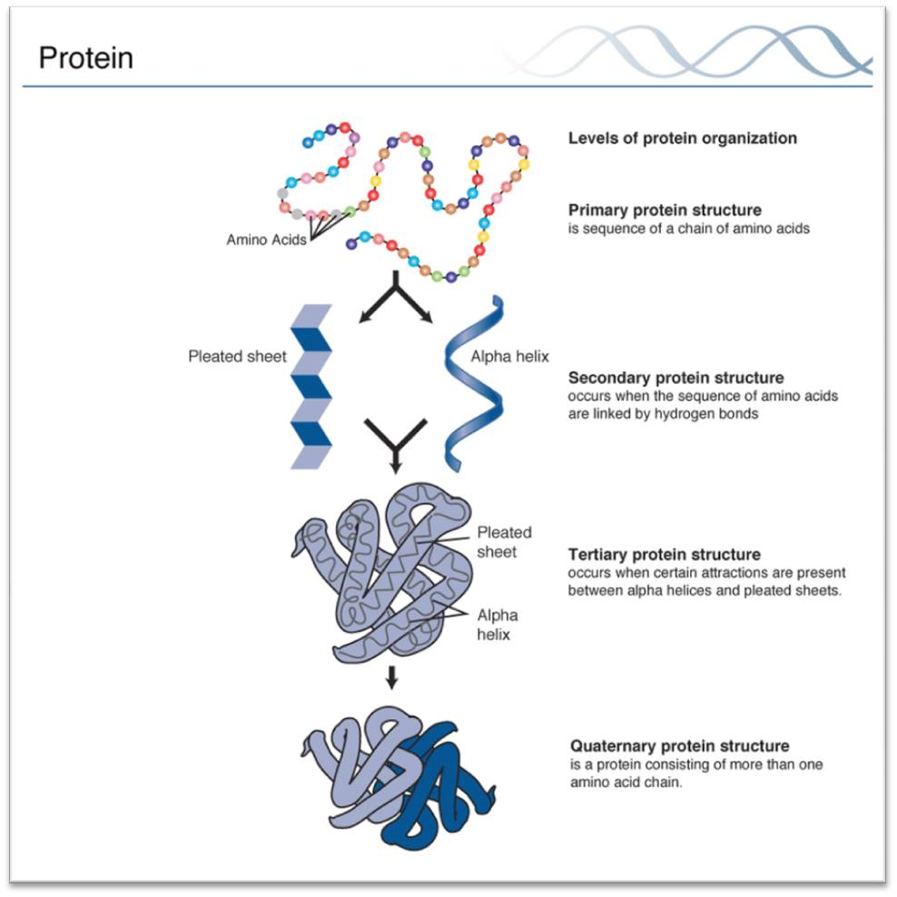

Globular and Fibrous Proteins

………………………………………………………………………………………………………

………………………………………………………………………………………………………

………………………………………………………………………………………………………

………………………………………………………………………………………………………

………………………………………………………………………………………………………

………………………………………………………………………………………………………

**Do these statement refer to globular or fibrous proteins?**

|  |  |
| --- | --- |
| * Little or no tertiary structure. | * Have complex tertiary and sometimes quaternary structures. |
| * Eg enzymes | * Eg haemoglobin |
| * Roles in metabolic reactions | * Eg keratin |
| * Eg collagen | * Usually insoluble. |
| * Folded into spherical (globular) shapes. | * Long parallel polypeptide chains. |
| * Cross linkages at intervals forming long fibres or sheets. | * Many have structural roles. |
| * Usually soluble as hydrophobic side chains in centre of structure. | * Eg insulin |

Test for protein:-

Functions of proteins

Proteins have a huge range of functions.

Task - research and write about four different proteins. Include how their structure is related to their function.

|  |
| --- |
| Further reading and questions  Section 1.6 textbook and summary questions, application page 22  Find “Big Picture Proteins” online |

**ENZYMES**

**Prior knowledge:**

Describe how enzymes work.

What is the effect of changing temperature / pH on enzymes?

**Enzymes are biological catalysts**

* They are made by living cells.
* They can be intracellular or extracellular.
* They regulate the chemical reactions which take place in many biological processes.
* They are required in very small amounts.
* They are used over and over again.

# Enzymes reduce activation energy

Enzymes work by lowering the amount of energy needed to start a reaction. Many reactions which give out energy are prevented from starting by an energy barrier – the **activation energy**. This is the energy required to break the existing bonds and start the reaction. An enzyme reduces the activation energy necessary to start a chemical reaction.

Graph to show how enzymes reduce activation energy:

# All enzymes are proteins

* Their activity depends on the tertiary structure of the protein.
* Each enzyme is coded for by one gene.

# Enzymes work by forming an enzyme-substrate complex

When enzyme and substrate molecules meet they react together reversibly at the active site to form an **enzyme-substrate complex**. This creates tension in the substrate molecule, which causes it to be converted to the products. These are released from the active site and the enzyme can be used again.

Enzyme + substrate(s) enzyme-substrate complex

Enzyme-substrate complex enzyme + product(s)

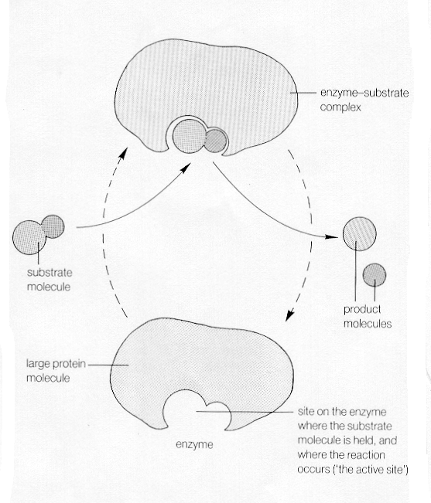

# Enzymes contain active sites

The **active site** of an enzyme is the region which can interact with the substrate. The enzyme-substrate complex forms when the substrate binds to the active site.

The **“lock and key”** theory stated that the substrates fitted perfectly into the active site, rather like a key unlocking a padlock.

The more recent **“induced fit”** model suggests that the substrate does not fit perfectly into the active site. The binding of the substrate induces a change in the shape of the enzyme molecule.

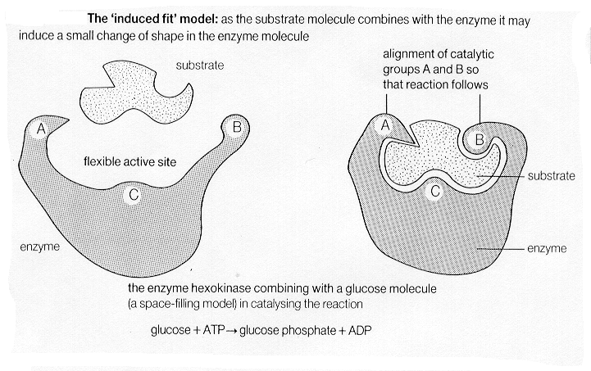

**Enzymes are specific**

Because there is a close relationship between the shape of the active site and the shape of the substrate, the majority of enzymes are highly specific.

The key to the specificity is the active site. The precise folding of the tertiary structure of a protein gives rise to an active site of very specific proportions that will only fit a specific molecule.

# Why is specificity so important?

…………………………………………………………………………………………………

…………………………………………………………………………………………………

# How does heating an enzyme affect its function?

…………………………………………………………………………………………………

…………………………………………………………………………………………………

# Naming of enzymes

Enzymes are usually named by the addition of the suffix –ase to the name of the substance acted upon, e.g. sucrose is split into glucose and fructose by the enzyme sucrase. Some enzymes still have more traditional names, for example pepsin and trypsin, which break peptide bonds in proteins.

# Enzymes are most effective at optimal conditions

Enzymes generally work best under certain narrowly defined conditions – the optimum.

Use pages 27-30 to draw graphs and explain the effects of the following conditions on enzymes:

1. Temperature

…………………………………………………………………………………………………

…………………………………………………………………………………………………

…………………………………………………………………………………………………

…………………………………………………………………………………………………

1. pH

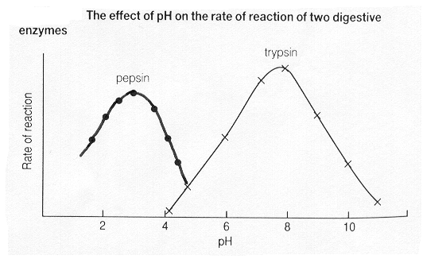

What are the optimum pHs for pepsin and trypsin?

………………………………………………………………………………………………

Why are they different?

………………………………………………………………………………………………

What is happening to trypsin at pHs 4 and 10?

………………………………………………………………………………………………

1. Substrate concentration

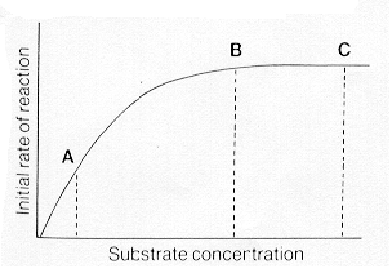

………………………………………………………………………………………………

………………………………………………………………………………………………

1. Enzyme concentration

………………………………………………………………………………………………

………………………………………………………………………………………………

………………………………………………………………………………………………

………………………………………………………………………………………………

Inhibitors – read pages 32 and 33. Draw diagrams here to show the difference between competitive and non-competitive inhibitors:

Enzymes key words

To score maximum marks in exam questions on enzymes there are certain key terms you need to use. Write one sentence which uses all of these key terms in the correct context:

Active site

Complementary

Enzyme-substrate complex

………………………………………………………………………………………………

………………………………………………………………………………………………

………………………………………………………………………………………………

|  |
| --- |
| Further reading and questions  Section 1.7 – 1.9 Textbook. Look at summary questions.  Application box page 31.  Further reading on metabolic pathways page 33.  End of chapter practice questions pages 34-35 |