Nucleic Acids

Prior knowledge from GCSE:

- Where is DNA found? .............................................................

- How many chromosomes does a human cell have? .................................................

- What is a gene?

..........................................................................................................................

- Who discovered the structure of DNA?

..........................................................................................................................

- What are the names of the four bases in DNA?

...................................... .......................................... ...................................... ........................................

- What is the base pair rule?

..........................................................................................................................

- How does DNA act as a code?

..........................................................................................................................

- What is a mutation?

..........................................................................................................................

DNA
DNA and its close relative RNA are perhaps the most important molecules in biology. They contains the instructions that make every single living organism on the planet.
DNA stands for …………………………… and RNA for ………………………………
They are polymers (long chain molecules) made from …………………………..
These have three parts to them:  - a phosphate group, which is negatively charged.  - a pentose sugar, which has 5 carbon atoms in it. In RNA the sugar is ribose. In DNA the sugar is deoxyribose.  - a nitrogenous base. There are five different bases | 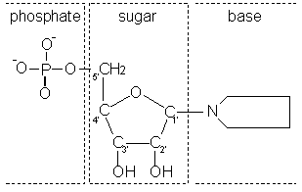
The Bases:
........................... (A), .............................. (T), .................................. (C), .............................. (G)

and ........................................(U)

Nucleotide polymerisation
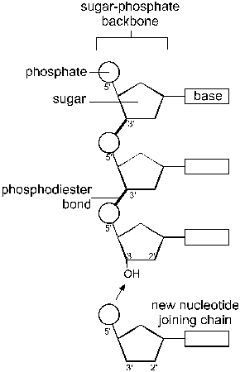 | Nucleotides polymerise by forming phosphodiester bonds between the carbon of the sugar and an oxygen atom of the phosphate.  The bases do not take part in the polymerisation, so the chain is held together by a sugar-phosphate backbone with the bases extending off it.  This means that the nucleotides can join together in any order along the chain. Many nucleotides form a polynucleotide.  A polynucleotide has a free phosphate group at one end and a free OH group at the other end.
Structure of DNA
The main features of the three-dimensional structure of DNA are:
- DNA is ……………… ……………….., so there are two polynucleotide stands alongside each other.
- The two strands are wound round each other to form a ……………………….. …………………………..
- The two strands are joined together by ………………………. bonds between the bases. The bases therefore form ………………….. …………………………, which are like rungs of a ladder.
- The base pairs are specific. ..................... only binds to ............................., and ...........................only binds to ...............................
- These are called complementary base pairs. This means that whatever the sequence of bases along one strand, the sequence of bases on the other strand must be complementary to it.
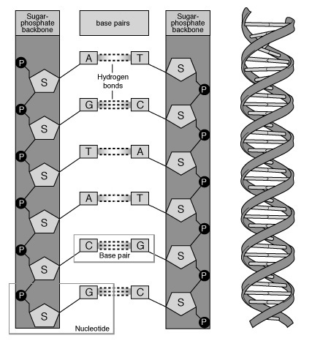

Function of DNA
DNA is the genetic material, and genes are made of DNA.
DNA therefore has two essential functions: replication and expression.
- Replication means that the DNA, with all its genes, must be copied every time a cell divides.
- Expression means that the genes on DNA must control characteristics. A gene is a section of DNA that codes for a particular protein. Characteristics are controlled by genes through the proteins they code for, like this:
Expression can be split into two parts: transcription (making RNA) and translation (making proteins). These two functions are shown in this diagram.
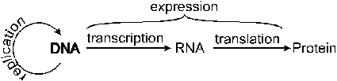
RNA
RNA is a nucleic acid like DNA, but with 4 differences:
- RNA has the sugar ........................................... instead of deoxyribose
- RNA has the base ................................ instead of thymine
- RNA is usually ......................................... stranded
- RNA is usually ..................................... than DNA

Messenger RNA (mRNA)
mRNA carries the "message" that codes for a particular protein from the nucleus (where DNA is) to the cytoplasm (where proteins are synthesised). It is single stranded and just long enough to contain one gene only.

Ribosomal RNA
Ribosomes are formed from RNA and proteins.
Transfer RNA (tRNA)
Transfer RNA is a molecule involved in the process of translation (of which more later).
DNA Replication

See page 42 and 43, and put together a flowchart to summarise the sequence of events that happens in DNA replication.

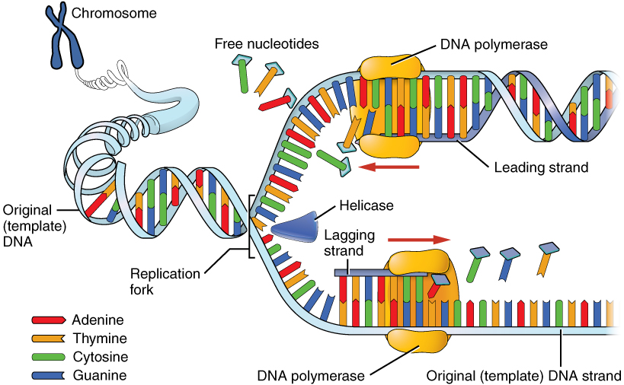
The Meselson-Stahl Experiment

This replication mechanism is sometimes called semi-conservative replication, because each new DNA molecule contains one new strand and one old strand.
There was an alternative theory which suggested that a "photocopy" of the original DNA was made, leaving the original DNA conserved (conservative replication).
The proof that the semi-conservative method was the correct method came from an experiment performed by Meselson and Stahl using the bacterium E. coli together with the technique of density gradient centrifugation, which separates molecules on the basis of their density.
Refer to sheet “experimental evidence for DNA”
Further reading and questions
Chapter 2.1 DNA and RNA structure especially experimental data purple box p.39-41.
Chapter 2.2 Replication especially Meselson Stahl experiment p. 44-45

