Water and ions

Water molecules are charged, with the oxygen atom being slightly negative and the hydrogen atoms being slightly positive. These opposite charges attract each other, forming hydrogen bonds. These are weak, long distance bonds that are very common and very important in biology.

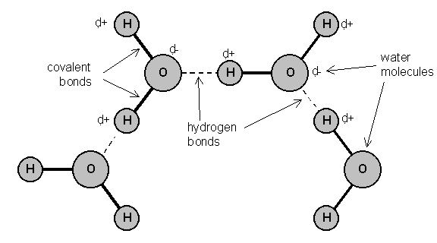

Water has a number of important properties essential for life. See “water questions” sheet and use chapter 2.4 of your textbook to answer them.

|  |
| --- |
| Further reading and questions:  Look at chapter 2.4 and answer the summary questions on page 49. |



**Specific heat capacity**

The specific heat capacity of a substance is the amount of energy needed to change the temperature of 1 kg of the substance by 1°C. Different substances have different specific heat capacities. The table shows some examples.

**Heat capacities of different substances**

| **Substance** | **Specific heat capacity in J / kg °C** |
| --- | --- |
| water | 4181 |
| oxygen | 918 |
| lead | 128 |

**Notice that water has a particularly high specific heat capacity.**

**Calculating specific heat capacity**

Here is the equation relating energy to specific heat capacity:

E = m × c × θ

* E is the energy transferred in joules, J
* m is the mass of the substances in kg
* c is the specific heat capacity in J / kg °C
* θ (‘theta’) is the temperature change in degrees Celsius, °C

For example, how much energy must be transferred to raise the temperature of 2 kg of water from 20°C to 30°C?

……………………………………………………………………………………………………………………………………………………………………………………………………………………………………………………………………………………………………………………………...

Ions

Prior knowledge: – When atoms form chemical bonds by transferring …………………….., they form ions. Atoms that lose electrons become …………………….. charged ions. Atoms that gain electrons become …………………. charged ions. Ions have the electronic structure of ………………………………...(group 0).

– Hydrogen ions, H+(aq),make solutions …………………….

– Mineral ions and vitamins are needed in small amounts for healthy functioning of the body.

– Internal conditions that are controlled include the ion content of the body – ions are lost via the ……………………. when we sweat and excess ions are lost via the ………………………….in the …………………………….

Ions task – hydrogen, iron, phosphate, sodium

In your group, one person is to find out about each type of ion, using the textbooks and internet. Look at page 49 to find out more on what you need to know for each ion. The group can then come back together to produce a summary table – you need to include where the ions are found in the body, what their function is, and how their properties relate to their function.

|  |
| --- |
| Further reading and questions:  Look at page 6 in your textbook for a bit of GCSE chemistry revision on ions, and attempt the questions on page 7. |

