Structure of eukaryotic cells
Prior knowledge from GCSE – draw and label an animal cell:-

Now a plant cell:-
Can you name the functions of the organelles that you have drawn?
Cells are the basic unit of structure and function in living things.
Some organisms consist of a single cell – unicellular – for example bacteria.
Other organisms are made of many cells – multicellular.
Most cells are extremely small and can only be seen with a microscope.

Units
1 metre (m) | = | 1000 millimetres (mm)
1 mm | = | 1000 micrometres (μm)
1 μm | = | 1000 nanometres (nm)
Bacteria are usually 0.5 – 10 μm.
Most plant and animal cells are in the size range 50 – 150 μm.
All plants, animals, fungi and protoctists have cells with a large, obvious nucleus, and other membrane bound organelles. These are called eukaryotic cells.
Bacteria contain no true nucleus and their cytoplasm does not have the organelles of eukaryotes. These are called prokaryotic cells.
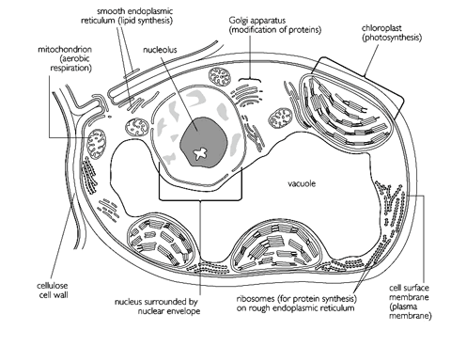
Eukaryotic cells

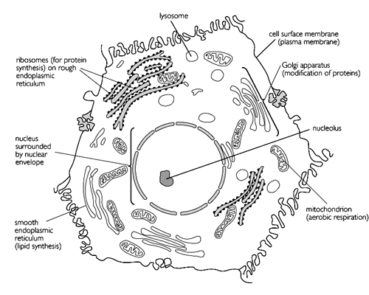
Cell wall
- Plant cell walls consist of cellulose together with other substances (mainly other polysaccharides)
- Hyphae of fungi and cell walls of prokaryotes have a similar structure but their chemical composition is different
- Animal cells do not have a cell wall
- The cytoplasm of one plant cell is joined to that of the next through gaps in the cell wall called plasmodesmata. The plasmodesmata are 25 nm wide and filled with cytoplasm and endoplasmic reticulum.
Function of the cell wall:
……………………………………………………………………………………………………………………………………
Cell membrane
- A thin, flexible layer around the outside of all cells
- Made of phospholipids and proteins
- More on this later!
Function of the cell membrane: ……………………………………………………………………………………………………………………………………

Overview of the Fluid Mosaic Model
Name | Brief description | Role of component
Phospholipids
Cholesterol
Proteins
Glycolipids
Glycoproteins

Nucleus
- Largest organelle in eukaryotic cell 10 – 20 μm in diameter
- All cells have one except
red blood cell which has none
phloem sieve cell which has none
- Surrounded by nuclear membrane (double membrane) – which has nuclear pores
- Contains genetic material – chromosomes usually diffused as chromatin except in cell division
- Nucleoplasm is a gel like matrix
- Ribosomes made in nucleolus
Function of the nucleus:
……………………………………………………………………………………………………………………………………
Mitochondria
(singular – mitochondrion)
- In EM appear as rod or cylinders
- Occur in large numbers, may be more than 1000 in metabolically active cells
- Size varies 0.5 – 1.5 μm wide, 3 – 10 μm long
- Double membrane, outer smooth, inner is folded to form cristae (large surface area). Inner membrane is site of ATP synthesis
- Space inside is called the matrix
- Contain DNA
Function of mitochondria:
……………………………………………………………………………………………………………………………………

Chloroplasts
- Chloroplasts are biconvex discs, 4 – 10 μm long and 2 – 3 μm wide
- In plants usually found in mesophyll cells of leaves, and cells of outer cortex of herbaceous stems
- Bound by double membrane
- Third membrane forms strands of branching membranes called lamellae or thylakoids. Stacks of thylakoids form grana – site of light reaction of photosynthesis.
- Grana are surrounded by stroma, where thylakoids are arranged loosely – site of dark reaction of photosynthesis
Function of chloroplasts:
……………………………………………………………………………………………………………………………………
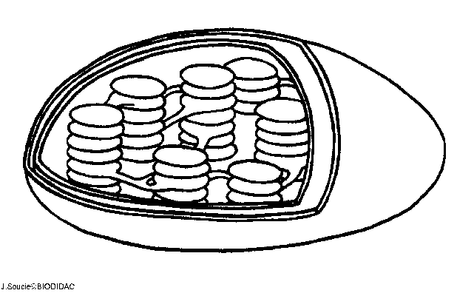
Endoplasmic Reticulum
- Network of folded membranes forming sheets, tubes and flattened sacs called cisternae
- Originates from outer membrane of nuclear membrane and is often still attached
- May have ribosomes e.g. RER – site of protein synthesis. Proteins are processed in RER before being exported from cell via Golgi body
- SER (smooth endoplasmic reticulum) concerned with lipid synthesis and transport
Function of ER:
……………………………………………………………………………………………………………………………………

Golgi apparatus
- Stack of membranous sacs called cisternae
- In all cells but most prominent in metabolically active
- Site of synthesis of biochemicals – packaged into swellings at margins which are pinched off as vesicles
- Collects proteins and lipids made in ER, adds additional substances and repackages
- Involved in formation of cell wall and lysosomes
Function of Golgi:
……………………………………………………………………………………………………………………………………
Ribosomes
- Two types – 70S (prokaryote) and 80S (eukaryote)
- 20 nm in diameter, consisting of two sub-units
- Many thousand per cell
- Made of protein and RNA
- Ribosomes free in cytoplasm are site of synthesis of proteins which are retained in the cell
- Ribosomes of RER are site of synthesis of proteins which are then secreted outside the cell
Function of ribosomes:
……………………………………………………………………………………………………………………………………
Vacuole
- Bounded by single membrane called tonoplast
- Older plant 80% of volume
- Filled with cell sap which is an aqueous solution of dissolved food material, ions, waste products and pigments
- Vacuole of animal cells much smaller and less permanent – small ones called vesicles and may contain engulfed solids or liquids
Function of vacuole:
……………………………………………………………………………………………………………………………………
Cytoplasm
- Fluid that remains when all organelles are removed is cytosol
- Contains
Aqueous solution of various essential mineral ions and soluble organic compounds e.g. sugars and amino acids
Soluble proteins, many of which are enzymes
Cell organelles
Network of fine strands of globular protein microtubules and microfilaments collectively referred to as cytoskeleton
- 90% water
- Site of certain metabolic pathways e.g. glycolysis
- Cytoplasmic streaming can occur – mass movement of cytoplasm seen in certain cells

Function of cytoplasm:
……………………………………………………………………………………………………………………………………
Lysosomes
- Small spherical vesicles 0.2 – 0.5 μm or larger (particularly in plant cells)
- Bounded by single membrane
- Concentrated mixture hydrolytic digestive enzymes called lysozymes
- Originate from Golgi or ER
- Can
Fuse with food vacuole
Dissolving of redundant structures
Be released in autolysis – when cell dies its own lysosomes release enzymes that digest the remains of the cell
- Contents are acidic and enzymes have a low optimum pH

Function of lysosomes:
……………………………………………………………………………………………………………………………………
Cell specialisation

In multicellular organisms, cells are specialised to perform specific functions. Similar cells are then grouped together into tissues, tissues into organs and organs into systems.

Draw an example of a specialised cell and describe how it is adapted to carry out its function:

.......................................................................................................................................................

.......................................................................................................................................................

Give an example of a tissue and describe how it is adapted to carry out its function:

.........................................................................................................................................

.........................................................................................................................................

Give an example of an organ in plants, and an organ in animals. List the different tissues found in these organs and describe how they help the organ to carry out its function:

Plants:...............................................................................................................................

.........................................................................................................................................

Animals:............................................................................................................................

.........................................................................................................................................

List seven organ systems found in humans, describe their main function and some of the organs found in each:
System | Function | Organs

Further reading and questions

Chapter 3.4 and 3.5. Complete summary questions.

Read the Big Picture magazine on cells here:
https://bigpictureeducation.com/cell

Extension for A* – for articles on cell biology topics look at Nature Scitable Cell Biology
http://www.nature.com/scitable/topic/cell-biology-13906536

