**Transport across membranes**

Prior knowledge from GCSE:

Give definitions for:

Diffusion

…………………………………………………………………………………………………………………………………………………………..

…………………………………………………………………………………………………………………………………………………………..

Osmosis

…………………………………………………………………………………………………………………………………………………………..

…………………………………………………………………………………………………………………………………………………………..

Active transport

…………………………………………………………………………………………………………………………………………………………..

…………………………………………………………………………………………………………………………………………………………..

Previous knowledge from cells topic – draw and label a diagram to show the different components of the cell surface membrane:

|  |
| --- |
|  |

See separate sheet to recap plasma membrane

Check that you know the STRUCTURE, ROLE and MOVEMENT of:

Phospholipids, proteins, glycoproteins, glycolipids and cholesterol.

Diffusion

Passive movement of molecules along a concentration gradient (from high to low concentration).

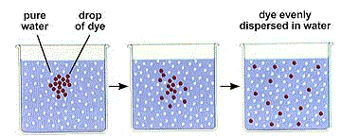

 Rate of diffusion is increased by:

* Increasing surface area over which it occurs.
* Decreasing distance over which it occurs.

Which substances can cross cell membranes?

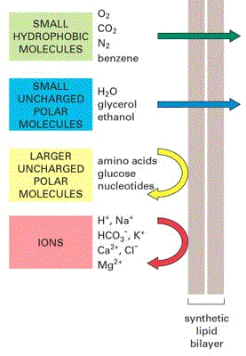

* Small uncharged solutes e.g. ethanol, carbon dioxide, oxygen, water - cross the lipid bilayer itself by simple diffusion.

|  |  |
| --- | --- |
|  |  |

Facilitated diffusion

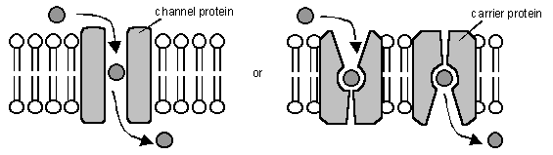

Facilitated diffusion is the transport of substances across a membrane by a trans-membrane protein molecule. The speed of facilitated diffusion is limited by the number of membrane proteins available.

The transport proteins tend to be specific for one molecule.

No energy is involved and substances can only move down their concentration gradient.

There are two kinds of transport protein:

* Channel Proteins form a water-filled pore or channel in the membrane. This allows charged substances (usually ions) to diffuse across membranes. Most channels can be gated (opened or closed), allowing the cell to control the entry and exit of ions.
* Carrier Proteins have a binding site for a specific molecule and constantly flip between two states so that the site is alternately open to opposite sides of the membrane (“ping-pong”).

Osmosis

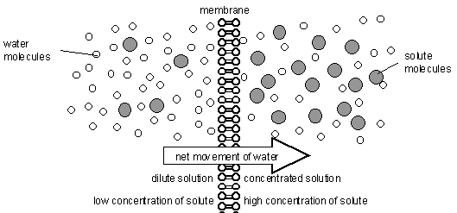

At A level – instead of talking about concentration of water we need to think about water potential.

Water potential (ψ) is a measure of the water molecule potential for movement in a solution. It is measured in units of pressure (kPa), and the rule is that water always moves by osmosis from less negative to more negative water potential. 100% pure water has ψ = 0, which is the highest possible water potential, so all solutions have ψ < 0 (i.e. a negative number).

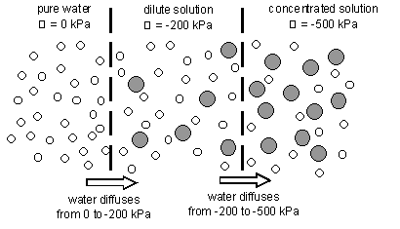

If the solution outside a cell is more dilute (hypotonic), it will have a higher (less negative) water potential, and water will move into the cell by osmosis.

If the solution outside a cell is more …………………………… (………………………………), it will have a …………………………… (………………… negative) water potential, and water will move …………………………………… the cell by osmosis.

If the solution outside the cell has an equal concentration (……………………………………), the water potential will be the same – what will happen?

|  |  |
| --- | --- |
| Active transport   * Energy is used * Transport against a concentration gradient. * Protein pumps change their shape * Pumps are specific * May transport two molecules at once |  |

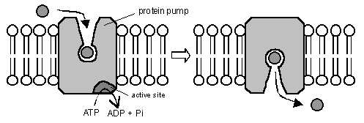

Active transport includes

* Ca2+ pumps in muscles
* Active reabsorption in nephrons
* Absorption of the products of digestion
* Sugar loading into phloem

|  |  |  |  |  |  |  |
| --- | --- | --- | --- | --- | --- | --- |
| **Bulk transport**  * Used to move large quantities of substances. * Endocytosis - in * Exocytosis - out | | |  | | | |
| **method** | **uses energy** | **uses proteins** | | **specific** | **controllable** |
| Simple Diffusion |  |  | |  |  |
| Osmosis |  |  | |  |  |
| Facilitated Diffusion |  |  | |  |  |
| Active Transport |  |  | |  |  |
| Vesicles |  |  | |  |  |

Co-transport and absorption of glucose – see diagram and information page 96.

Adaptations of cells to increase the rate of transport – page 95

Further reading and questions:

|  |
| --- |
| All of Chapter 4 – include summary questions and practise questions at the end of the chapter. |