Exchange of materials with the environment
Surface area : volume ratio
A continuous supply of oxygen from the environment to the cells of animals and plants is required for respiration.
Gas exchange occurs by diffusion. In order to obtain enough oxygen and remove carbon dioxide, a large, moist surface must be exposed to the environment.
The surface must be thin so that the distance between the source of oxygen and the cells requiring it or transporting it is small (short diffusion pathway).
the rate at which a substance can diffuse is given by Fick's Law:
Rate of diffusion ∝ surface area x concentration difference
Distance
So for efficient diffusion – systems need to have:
- .........................................................................................................................................
- .........................................................................................................................................
- .........................................................................................................................................

A diffusion gradient must be maintained using a ventilation mechanism and a transport system.
In small organisms e.g. protozoa, unicellular algae, the surface area is sufficiently large compared with volume that diffusion over the whole body surface obtains enough oxygen.
Organism | Length | SA (m²) | Vol. (m³) | S/A:Vol
bacterium | 1 m | 6 x 10⁻¹² | 10⁻¹⁸ | 6,000,000:1
amoeba | 100 m | 6 x 10⁻⁸ | 10⁻¹² | 60,000:1
fly | 10 mm | 6 x 10⁻⁴ | 10⁻⁶ | 600:1
dog | 1 m | 6 x 10⁰ | 10⁰ | 6:1
whale | 100 m | 6 x 10⁴ | 10⁶ | 0.06:1

As multicellular organisms are larger they are only able to use the whole body surface for obtaining oxygen if their energy demands are small, or if their shape is flattened (platyhelminthes).
Any further increase in size or metabolic rate requires the development of a specialised gaseous exchange system.
Organisms also need to exchange heat with their surroundings, and here large animals have an advantage in having a small surface area/volume ratio: they lose less heat than small animals. Small mammals and birds lose their heat very readily, so need a high metabolic rate in order to keep generating heat, as well as thick insulation.

General properties of gas exchange surfaces:-
- Large surface area to volume ratio.
- Moist, so diffusion can occur in solution.
- Thin, to maintain a short diffusion pathway.
- Transport, needed to maintain the diffusion gradient.
- Ventilation mechanism to allow a fresh supply of oxygen.

Gas exchange in insects

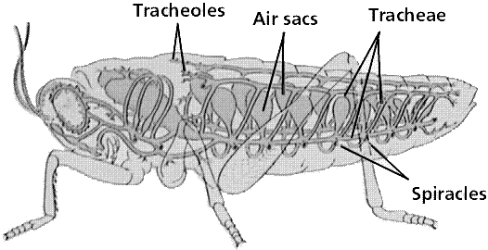

Gaseous exchange in bony fish
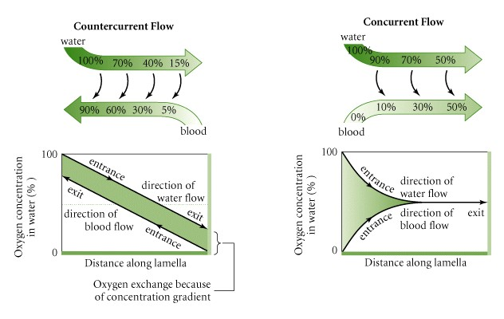
Ventilation in fish
Water flows in through the mouth of the fish over the gills and out through the operculum. The water flows in one direction only (unlike air in mammals).
Some fish achieve the flow of water simply by swimming, but others have a ventilation mechanism.
To take water into the mouth, the floor of the buccal (mouth) cavity is lowered, which ......................................... volume and ................................... pressure. Water therefore enters the mouth as it moves from an area of relatively ...................... pressure outside. During this stage, the operculum is closed.
Then the mouth closes and the buccal floor is ................................., decreasing the .......................................and increasing the ..................................... At the same time the operculum is ......................................, so water is therefore pushed out over the gills and out through the operculum.
Gas exchange in plants
In daylight photosynthesis is faster than respiration – so ......................................... diffuses out of the leaf and ........................................... diffuses in.
At night there is no photosynthesis so ............................................. diffuses in and ................................................................diffuses out.
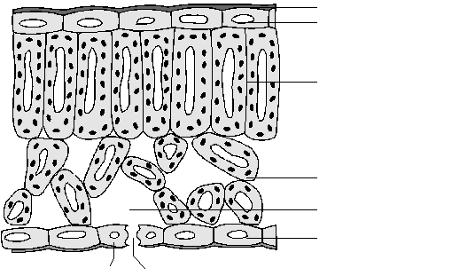
Xerophytes
Task – describe the xerophytic adaptations that allow plants to survive in dry conditions.

Gas exchange in the lungs

Mechanism of breathing in humans
The intercostal muscles and diaphragm move during breathing to alter the volume of the thorax.
There are two sets of intercostal muscles, the external which slant forwards and down and the internal which slant backwards.
These operate as antagonistic muscles - the external muscles contract to lift the rib cage up and out and the internal muscles contract to lower the rib cage.
The diaphragm has muscle fibres around the edge of a circular inelastic sheet of white fibres. When the muscle fibres are relaxed the diaphragm arches up into the thorax. When they contract the diaphragm is pulled flat across the thorax.
The table below shows the changes involved in breathing.

 | Inspiration | Expiration
External intercostals
Internal intercostals
Diaphragm
Thorax volume
Air pressure
Result

Lung capacity
The average lung capacity of a man is approximately 5 dm³.
During quiet breathing he will breathe in and out about 450 cm³ of air.
This is called tidal volume.
After a normal tidal inspiration a further 1500 cm³ of air may be inspired.
This is called the inspiratory reserve volume.
After a normal tidal expiration a further 1500 cm³ of air may be forced from the lungs.
This is called the expiratory reserve volume.
The amount of air exchanged after a forced inspiration followed immediately by a forced expiration is the vital capacity.
Even after a forced expiration of 1500 cm³ there is still air remaining in the lungs. This is called the residual air.
During inspiration about 300 cm³ of the tidal volume reaches the alveoli, the remaining 150cm³ remains in the respiratory tubes where gas exchange does not occur.
When expiration follows this air is expelled unchanged into the atmosphere and is called dead space air.
The air that reaches the alveoli mixes with the 1500 cm³ of air already present.
Its volume is small compared to the alveolar air and so complete renewal of air is slow. The composition of the alveolar air remains relatively constant at 13.8 % oxygen, 5.5 % carbon dioxide and 80.7 % nitrogen.
 | % Composition of:
Gas | Inspired air | Alveolar air | Expired air
Oxygen | 20.95 | 13.8 | 16.4
Carbon dioxide | 0.04 | 5.5 | 4.0
Nitrogen | 79.01 | 80.7 | 79.6

Using this information you can see that 20% of the oxygen inspired has been retained for use by the body and 100 times the amount of carbon dioxide expelled.
The nitrogen levels are relatively unchanged.
PVR = pulmonary ventilation rate.
PVR = Tidal volume x breathing rate

Alveoli
The bulk of the lung tissue consists of millions of microscopic air sacs called alveoli. They are surrounded by networks of capillaries, to give a good blood supply. The 700 million alveoli in the lungs of an adult human provide a large surface area for gas exchange.

The walls of the alveoli consist of squamous epithelium only 10 μm thick. Oxygen dissolves in the film of water on the surface of the wall, and then diffuses across the epithelial cells into the capillary. Once in the blood, the oxygen diffuses into the red blood cells to be carried by haemoglobin (more on this later). Carbon dioxide diffuses from the red blood cells into the plasma and then into the alveoli.
The capillaries are extremely narrow, so the red blood cells pass through slowly. This gives enough time for gas exchange to take place.

Smoking
Smoking tobacco greatly increases the risk of illness, disability and death from bronchitis, emphysema and lung cancer.
- Bronchitis
Cigarette smoke stimulates the secretion of mucus by goblet cells in the trachea, but damages the cilia (tiny hairs which sweep the mucus away, trapping dirt and microorganisms). This means that mucus accumulates in the bronchioles, and the irritation of the airways by the smoke is made worse because the cilia have lost their protective function. This can lead to inflammation, called bronchitis. The symptoms are recurring attacks of coughing and phlegm. As the bronchioles narrow, breathing can become difficult.
- Emphysema
Dust particles from tobacco smoke collect in the lungs, and this causes phagocytic cells of the immune system to increase in numbers. These cells release an enzyme called elastase which can damage the delicate structures of the alveoli. This reduces the area available for gas exchange, and leads to emphysema. People with emphysema become very short of breath, and this can cause death from respiratory failure, heart failure or chest infection.

- Lung cancer
Tobacco smoke contains carcinogenic chemicals which can cause tumour growth in the lungs. These tumours can spread through the lungs, and on to other organs.

- Smoking and pregnancy
Smoking while pregnant can decrease the availability of oxygen and nutrients to the foetus, because the nicotine and carbon monoxide reach the baby through the placenta. It is estimated to account for 20 to 30 percent of low-birth weight babies, up to 14 percent of preterm deliveries, and some 10 percent of all infant deaths. The odds of developing asthma are twice as high among children whose mothers smoke more than 10 cigarettes a day.

Smoke content | Effect on ventilation | Effect on gas exchange | Effect on pregnancy
Carbon monoxide | Increases ventilation rate | Reduces uptake of oxygen due to the formation of carboxy-haemoglobin | Hypoxia reduces availability of oxygen to the foetus so reduces rate of growth
Nicotine | Paralysis of cilia | Accumulation of mucus in bronchioles. Reduces gas exchange | N/A
Tar | Increases mucus production | Tumours, emphysema, bronchitis reduce area for gas exchange | N/A

Reading and questions
Chapter 6.1 surface area complete summary questions and applications
Chapter 6.2 insects
Chapter 6.3 fish
Chapter 6.4 + 6.5 plants
Chapter 6.6 – 6.8 humans

