Mass transport
Living things must be capable of transporting nutrients, wastes and gases to and from cells.
Single-celled organisms use their cell surface as a point of exchange with the outside environment.
Multicellular organisms do not have most of their cells in contact with the external environment and so have developed transport and circulatory systems to deliver oxygen and food to cells and remove carbon dioxide and metabolic wastes.

Components of the circulatory system include:

- blood: a connective tissue of liquid plasma and cells
- heart: a muscular pump to move the blood
- blood vessels: arteries, capillaries and veins that deliver blood to all tissues
The transport system delivers substances in bulk, dissolved or suspended in the blood which flows inside vessels. This is called mass flow.

Birds and mammals have a double circulation

How is the heart supplied with blood?
..............................................................................................................................................

Blood entering via vessel: | Organ | Blood leaving via vessel:
 | Head
 | Liver
 | Kidneys
 | Heart

Blood vessels

A blood vessel is a tube with a space in the centre, called the lumen, where blood flows.
The walls of arteries and veins consist of three layers. The innermost layer is squamous endothelium, the middle layer is made from smooth muscle and elastic fibres, and the outer layer is made from fibrous connective tissue.

Arteries are blood vessels that carry blood ..................................... the heart. They have thick walls to withstand the ....................................................... of blood caused by ventricular contractions. The diameter of arteries and the thickness of their walls steadily decrease as their distance from the heart increases.

Arteries divide into smaller vessels called arterioles, then into capillaries. In the capillary, the wall is only ....................................... thick. Capillaries branch into networks called into capillary beds. The circulatory system functions in the delivery of oxygen, nutrient molecules, and hormones; and the removal of carbon dioxide, ammonia and other metabolic wastes.

Capillaries are the points of exchange between the blood and surrounding tissues. Materials cross in and out of the capillaries by passing through or between the cells that line the capillary. Control of blood flow into capillary beds is done by nerve-controlled sphincters.

The extensive network of capillaries in the human body is estimated at between 50,000 and 60,000 miles long.
Veins have thinner walls than arteries. They also contain valves as blood is at lower pressure in the veins and backflow is therefore prevented. Blood leaving the capillary beds flows into a progressively larger series of .......................................... that in turn join to form veins. Veins carry blood from capillaries to the heart. With the exception of the ............................................. veins, blood in veins is oxygen-poor. The ..............................................veins carry oxygenated blood from lungs back to the heart. Pressure in veins is low, so veins depend on nearby muscular contractions to move blood along.

Vessel | Description
Arteries
Arterioles
Capillaries
Venules
Veins

Plasma, tissue fluid and lymph
The liquid part of the blood is called plasma and is composed of 91% water. In this water these other materials are suspended or dissolved.
- ........................................................................................................................................

- ........................................................................................................................................

- .......................................................................................................................................

- ........................................................................................................................................

- ........................................................................................................................................

- ........................................................................................................................................

The pumping action of the heart squeezes blood against the walls of the blood vessels creating an outward acting force called hydrostatic pressure.
Against this is the attraction of certain blood constituents for water, the osmotic pressure of the blood. This is caused mainly by the plasma proteins which have a large relative molar mass.
Filtration pressure causes substances to pass out of the blood through the permeable capillary walls into the tissue spaces.
These substances include all substances of small relative molar mass such as water, oxygen, glucose, amino acids, fatty acids, hormones and inorganic ions. The fluid formed is called tissue fluid.

The return of tissue fluid to the blood occurs in two ways:
- Proteins of high relative molar mass and blood cells remain in the capillaries so the colloid osmotic pressure is still the same.
The reduction in blood volume causes the hydrostatic pressure in the capillary to drop at the venous end of the capillary bed.
The filtration pressure is negative so water containing dissolved metabolic wastes such as carbon dioxide and metabolites in excess of the tissues' needs is absorbed back into the blood.
- The fluid not absorbed into the capillaries drains into blind ending lymphatic capillaries and is then known as lymph.
The lymphatic capillaries are similar in structure to blood capillaries. They drain all the tissues of the body into an extensive system of larger lymphatic vessels. Lymph is moved through the system by the contraction of nearby muscles. The vessels also contain veins to prevent backflow. One of the main functions of the lymphatic system is to remove materials that might otherwise accumulate in the tissues and impair normal function, e.g. accumulation of water in tissue fluid creates a swollen condition called oedema.
In the average healthy human 100cm³ of lymph is formed per hour. The lymphatic vessels return lymph to the blood through ducts joining the left and right subclavian veins.
The lymph passes through numerous lymph nodes as it passes around the body. These contain lymphocytes which engulf small particles, microbes and toxins. They are also involved in antibody production.

Blood
Plasma is about 60 % of a volume of blood; cells and fragments are 40%.

Component | Function
Red Blood Cells
White Blood Cells
Platelets

Red blood cells, also known as erythrocytes, are flattened, doubly concave cells about 7 µm in diameter that carry oxygen associated in the cell's haemoglobin.  Mature erythrocytes lack a nucleus.  The erythrocytes make up about 45% of the total blood volume in humans. | 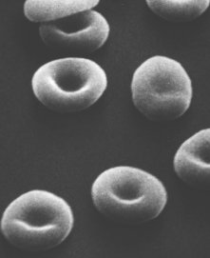

Carriage of oxygen in the blood
Haemoglobin is a complex molecule made up of four almost identical subunits. Each sub unit consists of a molecule of the protein globin attached to a central haem which contains an atom of iron.

Each haem is capable of combining with one molecule of oxygen, so a molecule of haemoglobin can carry four molecules of O₂.
Hb + 4O₂ HbO₈ oxyhaemoglobin
This occurs at high partial pressures of oxygen, i.e. in the alveolar capillaries of the lungs.
When the partial pressure of oxygen is low, as in the capillaries of active tissues the bonds holding the oxygen become unstable and oxygen is given up and diffuses out to the cells.

Oxygen dissociation curves
When the partial pressure of oxygen is plotted against the % saturation of haemoglobin an s-shaped curve called an oxygen dissociation curve results.
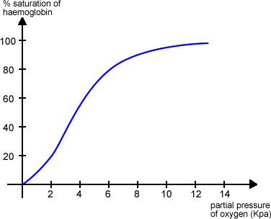
The curve is s-shaped because of the way in which the shape of the molecule is altered after each oxygen molecule is taken up.
After the first oxygen molecule is taken up the shape is altered such that it is easier for the second oxygen molecule to react and so on.
Also when oxygen is given up the first is given up readily but the others are given up less readily and only at a much reduced partial pressure of oxygen.
Over the steep part of the curve a small decrease in pp oxygen results in a big fall in the saturation of the haemoglobin, so that oxygen is released to the tissues where need is greatest.
Haemoglobin has a high affinity for oxygen where the oxygen tension is high (lungs) but a low affinity for oxygen where the oxygen tension is low (respiring tissues). This property makes haemoglobin an efficient respiratory pigment.

The Bohr effect
If the concentration of carbon dioxide is high, as it is in active tissues, the curve shifts to the right. This is because as the carbon dioxide concentration rises, the affinity of haemoglobin for oxygen is reduced; even if the partial pressure of oxygen remains unaltered the haemoglobin will give up its oxygen to the tissues. This is called the Bohr effect.
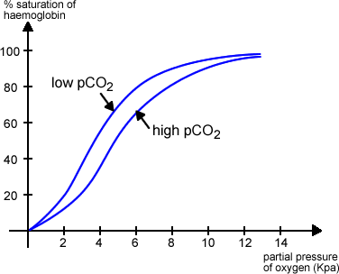
Foetal haemoglobin
Unloading of oxygen from the mother’s blood to the foetal circulation is brought about because the foetal haemoglobin has a greater affinity for oxygen than the maternal haemoglobin.
When the dissociation curves are compared, it can be seen that the curve for foetal haemoglobin is to the left of the curve for maternal haemoglobin. Therefore at equal partial pressures of oxygen the foetal haemoglobin will take up the oxygen from the maternal haemoglobin.
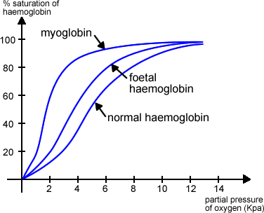
Myoglobin
The muscles of mammals contain a red pigment called myoglobin which is structurally similar to one of the four sub units of haemoglobin. Myoglobin has a higher affinity for oxygen than haemoglobin and unloads its oxygen only when the blood is almost fully deoxygenated. Note the curve is to the left of that for haemoglobin.
Oxymyoglobin acts as a reserve of oxygen in skeletal muscles.
Haemoglobin in other animals
Find out about an animal which has haemoglobin adapted to help it to survive in a particular environment.
Some examples: llama, lugworm, mouse, elephant.
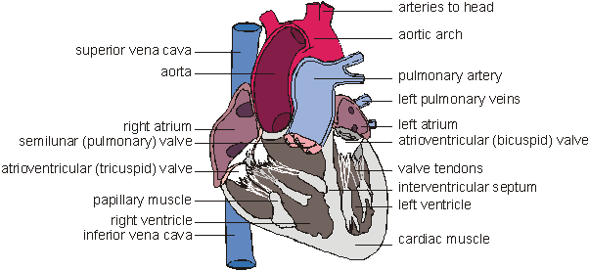
The human heart has four chambers: two thin-walled atria on top, which receive blood, and two thick-walled ventricles underneath, which pump blood. Veins carry blood into the atria andarteries carry blood away from the ventricles. Between the atria and the ventricles are atrioventricular valves, which prevent back-flow of blood from the ventricles to the atria. The left valve has two flaps and is called the bicuspid (or mitral) valve, while the right valve has 3 flaps and is called the tricuspid valve. The valves are held in place by valve tendons (“heart strings”) attached to papillary muscles, which contract at the same time as the ventricles, holding the vales closed. There are also two semi-lunar valves in the arteries (the only examples of valves in arteries) called the pulmonary and aortic valves.
The left and right halves of the heart are separated by the inter-ventricular septum. The walls of the right ventricle are 3 times thinner than on the left and it produces less force and pressure in the blood. This is partly because the blood has less far to go (the lungs are right next to the heart), but also because a lower pressure in the pulmonary circulation means that less fluid passes from the capillaries to the alveoli.
The heart is made of cardiac muscle, composed of cells called myocytes. When myocytes receive an electrical impulse they contract together, causing a heartbeat. Since myocytes are constantly active, they have a great requirement for oxygen, so are fed by numerous capillaries from two coronary arteries. These arise from the aorta as it leaves the heart. Blood returns via the coronary sinus, which drains directly into the right atrium.

The Cardiac Cycle [back to top]
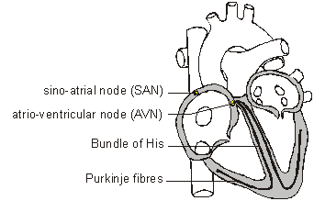
When the cardiac muscle contracts the volume in the chamber decrease, so the pressure in the chamber increases, so the blood is forced out. Cardiac muscle contracts about 75 times per minute, pumping around 75 cm³ of blood from each ventricle each beat (the stroke volume). It does this continuously for up to 100 years. There is a complicated sequence of events at each heartbeat called the cardiac cycle.
Cardiac muscle is myogenic, which means that it can contract on its own, without needing nerve impulses. Contractions are initiated within the heart by the sino-atrial node (SAN, or pacemaker) in the right atrium. This extraordinary tissue acts as a clock, and contracts spontaneously and rhythmically about once a second, even when surgically removed from the heart.
The cardiac cycle has three stages:
1. Atrial Systole (pronounced sis-toe-lay). The SAN contracts and transmits electrical impulses throughout the atria, which both contract, pumping blood into the ventricles. The ventricles are electrically insulated from the atria, so they do not contract at this time.
2. Ventricular Systole. The electrical impulse passes to the ventricles via the atrioventricular node (AVN), the bundle of His and the Purkinje fibres. These are specialised fibres that do not contract but pass the electrical impulse to the base of the ventricles, with a short but important delay of about 0.1s. The ventricles therefore contract shortly after the atria, from the bottom up, squeezing blood upwards into the arteries. The blood can't go into the atria because of the atrioventricular valves, which are forced shut with a loud "lub".
3. Diastole. The atria and the ventricles relax, while the atria fill with blood. The semilunar valves in the arteries close as the arterial blood pushes against them, making a "dup" sound.
The events of the three stages are shown in the diagram on the next page. The pressure changes show most clearly what is happening in each chamber. Blood flows because of pressure differences, and it always flows from a high pressure to a low pressure, if it can. So during atrial systole the atria contract, making the atrium pressure higher than the ventricle pressure, so blood flows from the atrium to the ventricle. The artery pressure is higher still, but blood can’t flow from the artery back into the heart due to the semi-lunar valves. The valves are largely passive: they open when blood flows through them the right way and close when blood tries to flow through them the wrong way.
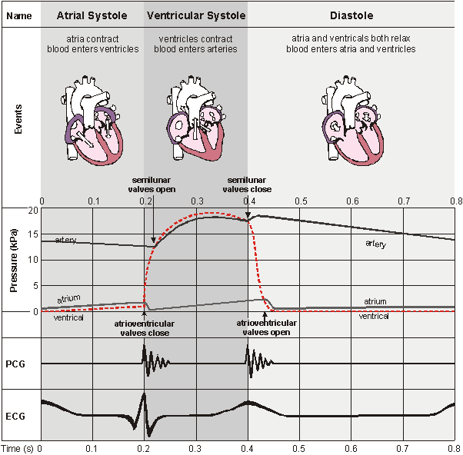
The PCG (or phonocardiogram) is a recording of the sounds the heart makes. The cardiac muscle itself is silent and the sounds are made by the valves closing. The first sound (lub) is the atrioventricular valves closing and the second (dub) is the semi-lunar valves closing.
The ECG (or electrocardiogram) is a recording of the electrical activity of the heart. There are characteristic waves of electrical activity marking each phase of the cardiac cycle. Changes in these ECG waves can be used to help diagnose problems with the heart.

Cardiovascular disease – see page 172-173 and separate sheet.

Further reading and questions

All of Chapter 7, summary questions and end of chapter questions

