DNA, genes and chromosomes

Prior knowledge:

Describe – genes, chromosomes and DNA to your partner. You can use a whiteboard to draw pictures if it helps. What is the relationship between the three?

Draw a nucleotide. Explain the structure of DNA.

Genes and the genetic code

What is a gene?

……………………………………………………………………………………………………………………………………………………………………………………………………………………………………………………………………………………………………………………………………………………

What is a locus?

…………………………………………………………………………………………………………………………………………………………………………

What is an allele?

…………………………………………………………………………………………………………………………………………………………………………

The structure of DNA makes it well-suited to its job of storing and expressing genetic information.

· The bases are protected on the inside of the molecule and the two strands are held together by numerous hydrogen bonds, so DNA is a very stable molecule and is not easily damaged.

· There are four different bases, which can appear in any order, so their sequence can encode information, like writing with a 4-letter alphabet.

· DNA is a very long molecule, so it store a great deal of information (human DNA has 3 billion basepairs).

· The two complementary strands means there are two copies of the information, which is useful for repair, copying and error checking.

DNA and the Genetic code

The role of DNA is to instruct the cell to make specific proteins.

The huge length of the DNA molecule in a chromosome codes for a very large number of proteins – within this the relatively short length of DNA that codes for a single protein is called a gene.



Gene expression can be split into two parts:

transcription (making RNA) and translation (making proteins).



The DNA of different species differs not in the chemicals which it comprises, but in the sequence of base pairs along its length. The sequence must be a code that determines which proteins are manufactured .

The Triplet Code

Explain why you need a triplet code for DNA to code for amino acids:

……………………………………………………………………………………………………………………………………………………………………………………………………………………………………………………………………………………………………………………………………………………………………………………………………………………………………………………………………………………………………………………………………………………………………………………………………………………………………………………………………………………………………………………………………………………………………………………………………………………………………………………………………………………

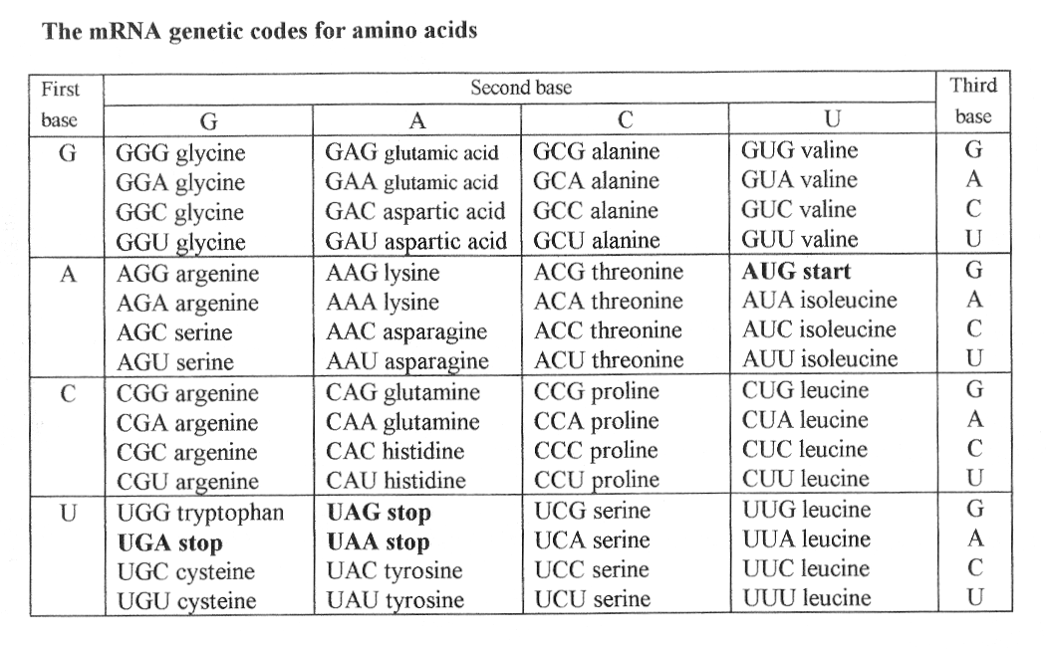

NOTE YOU DO NOT NEED TO LEARN ANY OF THESE CODES!!!

You will notice that some amino acids are coded for by more than one sequence of three bases. A code like this is said to be ……………………………

The code is …………………………. – each set of three bases is only read once.

The code is ………………………………. – the same set of three bases codes for the same amino acid in all organisms.

Also note that some codes do not refer to amino acids – i.e. the start and stop codons. These show the start and finish of the gene.

DNA and Chromosomes

Highlight key terms in the paragraphs below and then provide definitions:

The DNA molecule in a single human cell is 1 m long, so is 10 000 times longer than the cell in which it resides (< 100mm). (Since an adult human has about 1014 cells, all the DNA is one human would stretch about 1014 m, which is a thousand times the distance between the Earth and the Sun.) In order to fit into the cell nucleus the DNA in eukaryotes is cut into shorter lengths and each length is tightly wrapped up with histone proteins to form a complex called chromatin.

Just before cell division the DNA is replicated, and more histone proteins are synthesised, so there is temporarily twice the normal amount of chromatin. Following replication the chromatin then coils up even tighter to form short fat bundles called chromosomes. These are about 100 000 times shorter than fully stretched DNA, and therefore 100 000 times thicker, so are thick enough to be seen with the light microscope. Each chromosome is roughly X-shaped because it contains two replicated copies of the DNA.

The two arms of the X are therefore identical. They are called chromatids, and are joined at the centromere. (Do not confuse the two chromatids with the two strands of DNA.) The complex folding of DNA into chromosomes is shown below.

In eukaryotic cells, DNA is also found in mitochondria and chloroplasts. This DNA is short, circular and not associated with proteins.



**Prokaryotic DNA**

DNA in prokaryotes has the same structure to DNA in eukaryotes, and in fact is used in genetic engineering techniques where bacterial DNA can be inserted into eukaryotic DNA, where it functions normally.

However:

· Prokaryotic DNA is much shorter

· Prokaryotic DNA circular (i.e. a closed loop)

· Prokaryotic DNA is not associated with histone proteins.

Introns and exons

………………………………………………………………………………………………………………………………………………………………………………………………………………………………………………………………………………………………………………………………………………………………………………………………………………………………………………………………………………………………………………………………

|  |
| --- |
| Further reading and questions  Look at sections 8.1 and 8.2  Summary questions page 203, 207 **maths question 4**  Application box page 204  Extension – find out more about mitochondrial DNA, particularly in relation to mitochondrial inherited disorders and “three person embryos”.   * Why do scientists think that mitochondria and chloroplasts contain DNA? |