Variation

* Variation means the differences in characteristics (phenotype) between organisms.
* There is variation within each species – intraspecific variation.
* Also, there are differences between different species – interspecific variation.

## Causes of variation

There are many causes of variation:

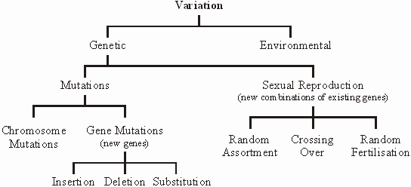

**Natural selection**

Look at page 229 – 230 and produce a flow chart / list of key points of natural selection, on paper.

Then apply these points to an example – you could use *Biston betularia* see page 230

Natural selection results in species that are better adapted to the environment that they live in - these adaptations can be

* Anatomical
* Physiological
* Behavioural

See page 234 for examples.

## Types of Natural Selection - selection and change in allele frequency

### 1.Directional Selection

This occurs whenever the environment changes in a particular way. There is therefore selective pressure for species to change in response to the environmental change e.g.

* The peppered moth (studied by Kettlewell). These light coloured moths are well camouflaged from bird predators against the pale bark of birch trees, while rare mutant dark moths are easily picked off. During the industrial revolution in the 19th century, birch woods near industrial centres became black with pollution. In this changed environment the black moths had a selective advantage and became the most common colour, while the pale moths were easily predated and became rare.
* Bacterial resistance to antibiotics. Antibiotics kill bacteria, but occasionally a chance mutant appears that is resistant to that antibiotic. In an environment where the antibiotic is often present, this mutant has an enormous selective advantage since all the normal (*wild type*) bacteria are killed leaving the mutant cell free to reproduce and colonise the whole environment without any competition. Some farmers routinely feed antibiotics to their animals to prevent infection, but this is a perfect environment for resistant bacteria to thrive. The best solution is to stop using the antibiotic so that the resistant strain has no selective advantage, and may die out.

Populations do not have to decide to adapt, or mutate, after an environmental change.  The mutation, or combination of alleles giving resistance, have to already be there by chance, otherwise the population may become extinct.

"Environment" includes biotic as well as abiotic, so organisms evolve in response to each other. e.g. if predators run faster there is selective pressure for prey to run faster, or if one tree species grows taller, there is selective pressure for other to grow tall. Most environments do change (e.g. due to migration of new species, or natural catastrophes, or climate change, or to sea level change, or continental drift, etc.), so directional selection is common.

### 2.Stabilising (or Normalising) Selection.

This occurs when the environment doesn't change. Natural selection doesn't have to cause change, and if an environment doesn't change there is no pressure for a well-adapted species to change. Fossils suggest that many species remain unchanged for long periods of geological time.

Another example of stabilising selection can be seen in the birth weight of humans.  The heaviest and lightest babies have the highest mortality and are less likely to survive to reproduce and pass on their alleles.

### 3.Disruptive (or Diverging) Selection.

This occurs where an environment change may produce selection pressures that favour two extremes of a characteristic e.g.

* Grass plants in Welsh Copper mines. Soil contaminated by copper from the mines is lethal to normal grass plants, but a chance mutation allowed one plant to grow. This plant prospered and reproduced, but only on the contaminated soil. On normal soil it grew more slowly than the normal plants and was easily out-competed. So now there are two varieties growing close together.

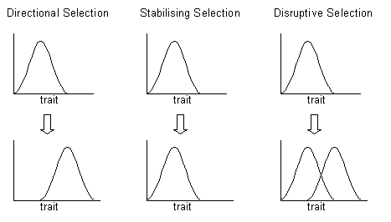



|  |
| --- |
| Further reading and questions  Chapters 9.3 and 9.4 textbook do summary questions.  Application about cuckoos page 234.  Watch “crash course biology” natural selection on Youtube. |