Biodiversity within a community

Definitions:

Biodiversity

…………………………………………………………………………………………………………..

Species diversity

…………………………………………………………………………………………………………..

Genetic diversity

…………………………………………………………………………………………………………..

Ecosystem diversity

…………………………………………………………………………………………………………..

Species richness

…………………………………………………………………………………………………………..
Techniques for measuring diversity
Find out about the following ecological techniques.
- Frame and point quadrats
- Line and belt transects
- Netting and trapping
- Random sampling

Diversity index
This is a formula for calculating the diversity of an ecosystem.
d = N (N – 1)
∑ n (n - 1)
Where N = total number of organisms of all species
and n = total number of organisms of each species
When collecting data for a diversity index, it is necessary to count numbers of organisms, for example by using a point quadrat.
Look at the worked example on page 244 of textbook, then answer the summary questions on that page.
- Why is the index of diversity a more useful measure than counting the number of species in an area?
…………………………………………………………………………………………………………..
…………………………………………………………………………………………………………..
Abiotic and biotic factors
For an individual community there are many factors which can affect the number of species present – abiotic or biotic.
Biotic factors | Abiotic factors

Stability of ecosystems
In extreme environments fewer species are able to survive. In these extreme environments it is the abiotic factors which dominate the distribution and abundance of species.
Biotic factors are more important when the environment is less hostile, as the diversity of organisms is high. The longer the community has existed, the more species will have had the opportunity to join it – e.g. the longer a tree species has been in British woodland, the more insect species are associated with it (oak, 9000 years, 284 insect species: horse chestnut, 400 years, 4 insect species). All these factors interact, for example if the environment is harsh, a species that is not competitive in an easier environment might be more able to survive there.

Relationship between stability and diversity
Are diverse communities more stable? Consider a community with only a handful of species. The food web may well contain predators which only have a single prey species. The chance extinction of that prey species would then lead to the extinction of its predator. In a more diverse community this would have less extreme consequences.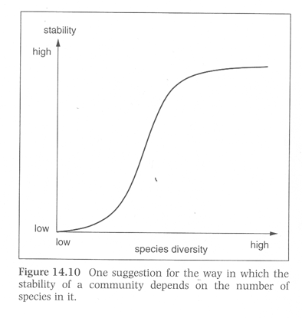
However, the interactions between species are also important, and there may be some that are more vital to the community than others.
Human influences on diversity
How has agriculture impacted biodiversity?
…………………………………………………………………………………………………………..
…………………………………………………………………………………………………………..
…………………………………………………………………………………………………………..
…………………………………………………………………………………………………………..
How can farmers help conservation?
…………………………………………………………………………………………………………..
…………………………………………………………………………………………………………..
…………………………………………………………………………………………………………..
…………………………………………………………………………………………………………..

Biological conservation

Maintaining species diversity (biodiversity) within a habitat.

Ecological study of threatened habitats to inform their management.

Control of introduced species.

Biodiversity action plans – from the Rio Earth Summit in 1992

Six reasons why maintaining biodiversity is important

Moral reasons

Aesthetic reasons

Importance of individual species in maintaining the ecosystem

Benefit to people – fisheries, tourism, industry, medicines, agriculture, forestry

Maintaining evolutionary processes

Insurance – we do not know which species will be useful in the future

Further reading and questions:

Section 10.3 textbook look at summary questions.
application on page 248.

Watch BBC programme “secrets of our living planet” episode 1 “the emerald band” – google it!

