Gas Exchange

- Cut out the diagram below and stick it into your book. Complete the labels.

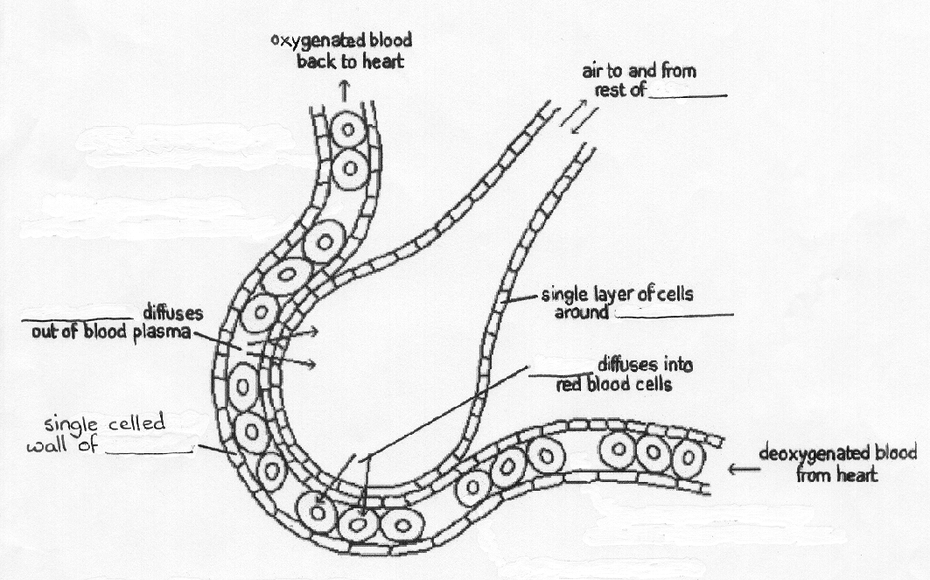
- What is this structure called and where is it found?

- Colour the blood cells – blue for low oxygen concentration and red for high oxygen concentration.

- What is gas exchange?

- Why is gas exchange necessary?

- Write down three ways in which this structure is adapted to make gas exchange as efficient as possible.
Human Respiratory System

- Cut out the diagram below and stick it into your book. Complete the labels.

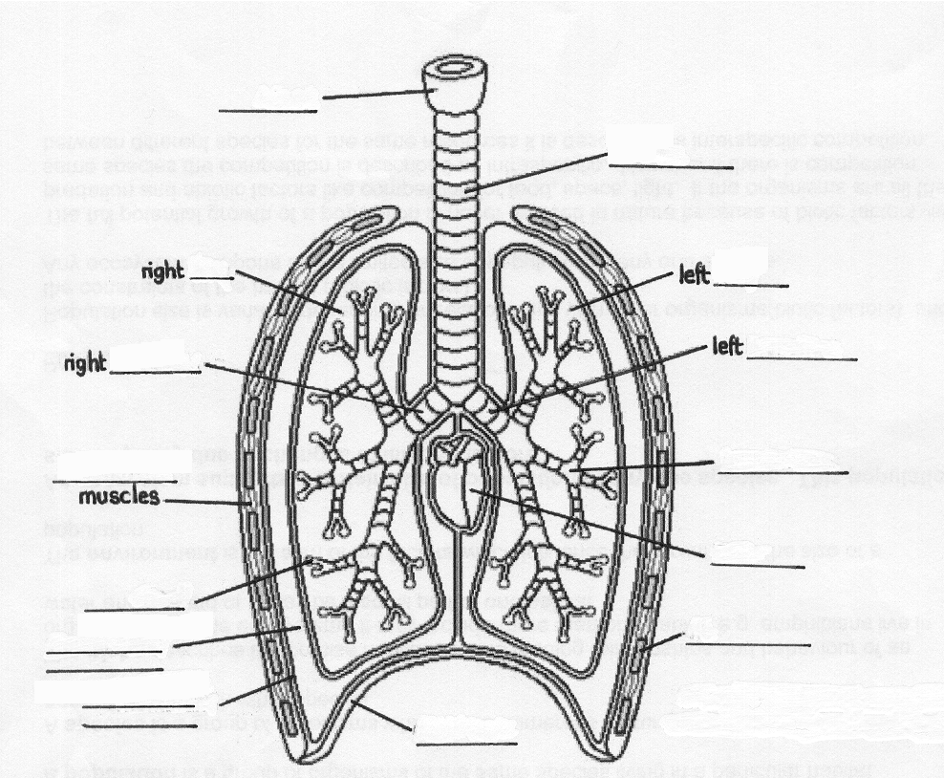

- Colour the heart in red and the pleural cavity in blue.

- Where exactly in the lungs does gas exchange take place?

- Copy and complete the following sentences.

  - The ……………………………… is a sheet of muscle which moves down, drawing air into the …………………………
  - The ……………………… and ………………………… ………………………… together help to protect the lungs.
  - Another name for the windpipe is the …………………………… This has bands of ………………………… around it to hold it open. The …………………………… then divides into two tubes called the left and right …………………………… These split into smaller tubes called ………………………………, which lead into air sacs called ………………………………

The mechanism of breathing

- Cut out the diagram below and stick it into your book. Complete the labels.
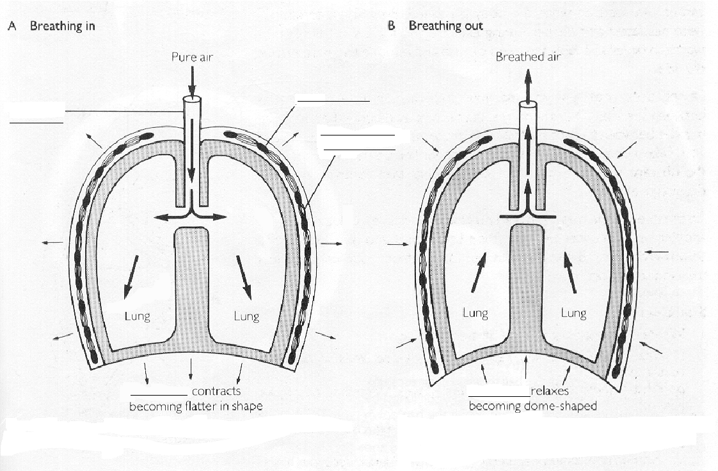2. Copy and complete the following paragraph using the words provided. Each word is used
once only.
downwards | outwards | increase
exchange | oxygen | carbon dioxide | upwards | pressure
fresh | exhalation | intercostal muscles | decreases | relax
surface | ventilated | inhalation | increases | inwards

For the efficient ……………………………… of gases (uptake of …………………………… and release of …………………………… ………………………………), the air around the actual exchange ……………………………… must not be allowed to become stale. To prevent this happening the surface must be ………………………………… This process involves drawing in …………………………… air, which is called ……………………………., and removing some of the used air, which is called ……………………………………
To breathe in, the diaphragm and the ………………………………… ………………………………… contract. This moves the diaphragm ……………………………… and the ribcage …………………………………. This ……………………………….. the volume of the chest, and a decrease in the ……………………………………, which causes air to be drawn into the lungs. When the diaphragm and intercostal muscles ………………………………… , the diaphragm springs back ……………………………… and the ribs move ……………………………… This ………………………………… the volume and …………………………………… the pressure, forcing air out of the lungs.

