Examples of mutations – copy this table into books
What is the mutation? (summarise!) | Is it Neutral, Harmful or Beneficial?

Example 1 - Antibiotic resistance
A mutation in the bacterial DNA can lead to antibiotic resistance. In a large population of bacteria, there may be some cells that are not affected by the antibiotic. These cells survive and reproduce, producing even more bacteria that are not affected by the antibiotic. More on this when we do natural selection next week!

MRSA
MRSA is the acronym for 'methicillin-resistant Staphylococcus aureus'. It's very dangerous because it's a strain of bacterium that is resistant to most antibiotics. To slow down or stop the development of other strains of resistant bacteria, we should always:
- avoid the unnecessary use of antibiotics
- complete the full course.

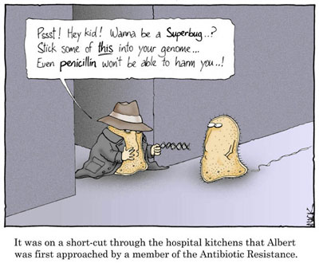

Example 2

Sickle cell disease
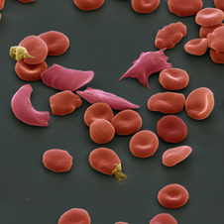
Sickle cells
Sickle cell disease is a recessive condition so the sufferer has two copies of a faulty gene. The red blood cells of sufferers are misshapen and can stick together which can block blood vessels. Sickle cell disease sufferers can become very tired and quickly get out of breath. If the sickle cells block a blood vessel, this can be fatal.
However if a person is a carrier for sickle cell, e.g. has only one copy of the mutated gene, then this gives them protection against malaria.

Example 3
Cystic Fibrosis
Cystic fibrosis (CF), is a recessive genetic disorder that affects most critically the lungs, and also the pancreas, liver, and intestine.
Difficulty breathing is the most serious symptom and results from frequent lung infections that are treated with antibiotics and other medications. Other symptoms, including sinus infections, poor growth, and infertility affect other parts of the body.
CF is caused by a mutation in the gene for the protein CFTR. This protein is required to regulate the components of sweat, digestive fluids, and mucus.
Example 4

Peppered moths
Before the industrial revolution in Britain, most peppered moths were of the pale variety. This meant that they were camouflaged against the pale birch trees that they rest on. Moths with a mutant black colouring were easily spotted and eaten by birds. This gave the white variety an advantage, and they were more likely to survive to reproduce.
Airborne pollution in industrial areas blackened the birch tree bark with soot. This meant that the mutant black moths were now camouflaged, while the white variety became more vulnerable to predators. This gave the black variety an advantage, and they were more likely to survive and reproduce. Over time, the black peppered moths became far more numerous in urban areas than the pale variety.
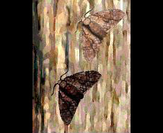
The pale peppered moths camouflage well against the pale birch tree
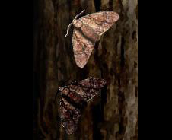
The darker mutant peppered moths camouflage well against the blackened birch tree

Example 5
Hypertrichosis is also called “werewolf syndrome” or Ambras syndrome, and it affects as few as one in a billion people; and in fact, only 50 cases have been documented since the Middle Ages.
People with hypertrichosis have excessive hair on the shoulders, face, and ears. Studies have implicated it to a rearrangement of chromosome 8. Normally, signals from the dermis send the messages to form follicles. As a follicle forms, it sends signals to prevent the area around it from also becoming a follicle, which results in the equal spacing of our five million or so follicles. Most of our body parts ignore the messages to form follicles, which explains why most of us are relatively hairless.
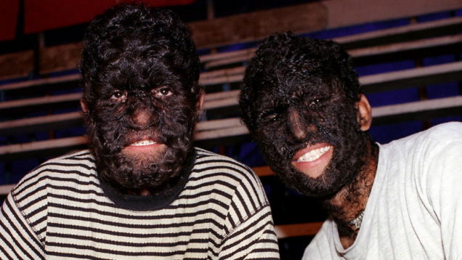

Example 6 – mouse marking
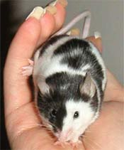
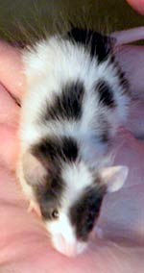
Lab name: Piebald
Genotype: s/s
Chromosome: 14
Originated: Spontaneous mutation (very old mutation, dating back to around the 1920's)
Show class: Piebald can look like many show classes depending on spotting pattern;
Broken: The mouse should have clean cut, even spots. Both white spots and colored markings should cover 50% of the mouse.
Even Marked: Spots should be clean-cut and spread evenly throughout the coat. Spots should mirror each other on both sides of the mouse.
General description: Piebald is often referred to as "cow marked" (slang) because of its tenancy to distribute cow-like markings. However, they can mimic a lot of different spotting genes.
Example 7 – polydactyly
This means having extra fingers or toes. Polydactyly is associated with different mutations, either mutations in a gene itself or in a protein responsible for the expression of a gene – whether the gene is switched on or off. The extra digit is usually a small piece of soft tissue that can be removed. Occasionally it contains bone without joints; rarely it may be a complete, functioning digit. The world record holder for highest number of digits is Akshat Saxena from Uttar Pradesh, India. He was born in 2010 with 7 digits on each hand and 10 digits on each foot, for a total of 34 digits.
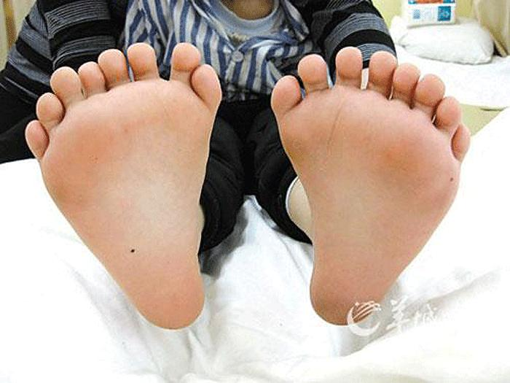

Example 8 – albinism
Albinism affects production of melanin, the pigment that colours the hair, skin and eyes
It is estimated that about one in 17,000 people in the UK has some form of albinism.
People with albinism have a reduced amount of melanin or no melanin at all.
Depending on the amount of melanin a person has, they may have very pale hair, skin and eyes, but some may have brown or ginger hair and skin that can tan.
People with albinism usually have a number of eye conditions such as:
photophobia (sensitivity to light) – they may feel dazzled by bright light
problems with eyesight – they may benefit from wearing glasses, although vision is often still impaired even with glasses (see below)
involuntary eye movements (nystagmus)
A person with albinism will need to take extra care in the sun. Without melanin in their skin, ultraviolet (UV) rays in sunlight can easily damage their skin (sunburn).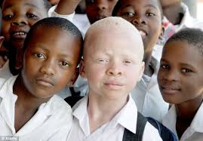
Example 9 – lactose tolerance
Originally, humans became lactose intolerant from the age of about 4 or 5, once they were weaned. This happened as the body stopped producing lactase, the enzyme that digests the lactose suger in milk.
At around 10, 000 BC a genetic mutation appeared that caused the lactase production gene to stay switched on. People with this mutation could continue to drink milk. This mutation then spread throughout Eurasia to Britain, Europe and India. 80% of Europeans became milk drinkers.
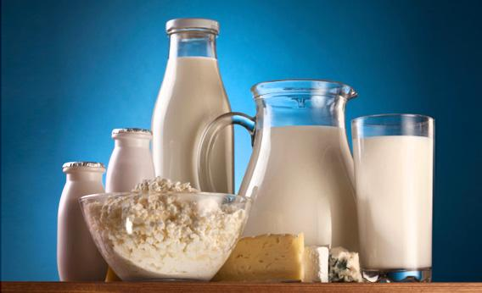
Example 10

Mutations: plant
Plant mutations, known as sports, breaks, or chimeras, are naturally occurring genetic mutations that can change the appearance of the foliage, flowers, fruit or stems of any plant.
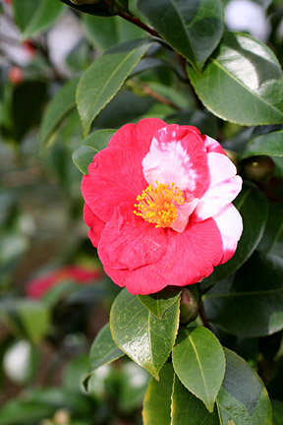

Symptoms
A naturally occurring genetic mutation, sometimes known as a sport or a break, causes a sudden change in the appearance of a plant. There are many ways this will show. You may notice coloured flecks in a white flower, or a perennial with single flowers might develop a stem that holds a double flower. Mutation can also cause a change in foliage colour or fruit appearance. Reversion is a form of plant mutation.
Generally, you may only notice one or two mutations on a plant, for example, there might be just one different coloured flower on a plant. Usually the plant will revert back to its original form the following year.

