Challenge 1

FIND OUT?

Use a textbook or the internet to find out about:

ELECTRON MICROSCOPES

What are they?

How do they work?

How are they different from the microscopes that you have used?

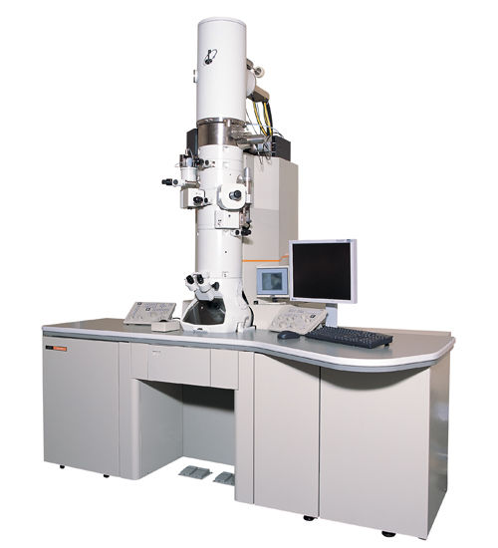

Challenge 2

WHAT IF?

Microscopes had not been invented.

What might we not know about?

Would this cause problems?

How could we solve those problems?

Challenge 3

CELLS CROSSWORD

|  |  |  |  |  |  |  |  |  |  |
| --- | --- | --- | --- | --- | --- | --- | --- | --- | --- |
| 1C | Y | T | 2O | P | L | A | 3S | M |  |
| H |  |  | V |  |  |  | A |  |  |
| L |  |  | A |  |  |  | P |  | 4M |
| O |  |  |  |  | 5P |  |  |  | I |
| 6R | E | D |  |  | O |  |  |  | T |
| O |  |  |  |  | L |  |  |  | O |
| P |  |  |  | 7P | L | A | 8 N | T | S |
| 9L | E | A | F |  | E |  | U |  | I |
| A |  |  |  |  | N |  | C |  | S |
| S |  |  |  |  |  |  | L |  |  |
| 10 T | A | I | L |  | 11S | P | E | R | M |
|  |  |  |  |  |  |  | U |  |  |
| 12C | E | L | L | U | L | O | S | E |  |

Here are some crossword answers. Can you work out the clues?

Challenge 4

MINI CONCEPT MAPS – body systems

Copy and Complete these mini concept maps.

Add more for other systems.

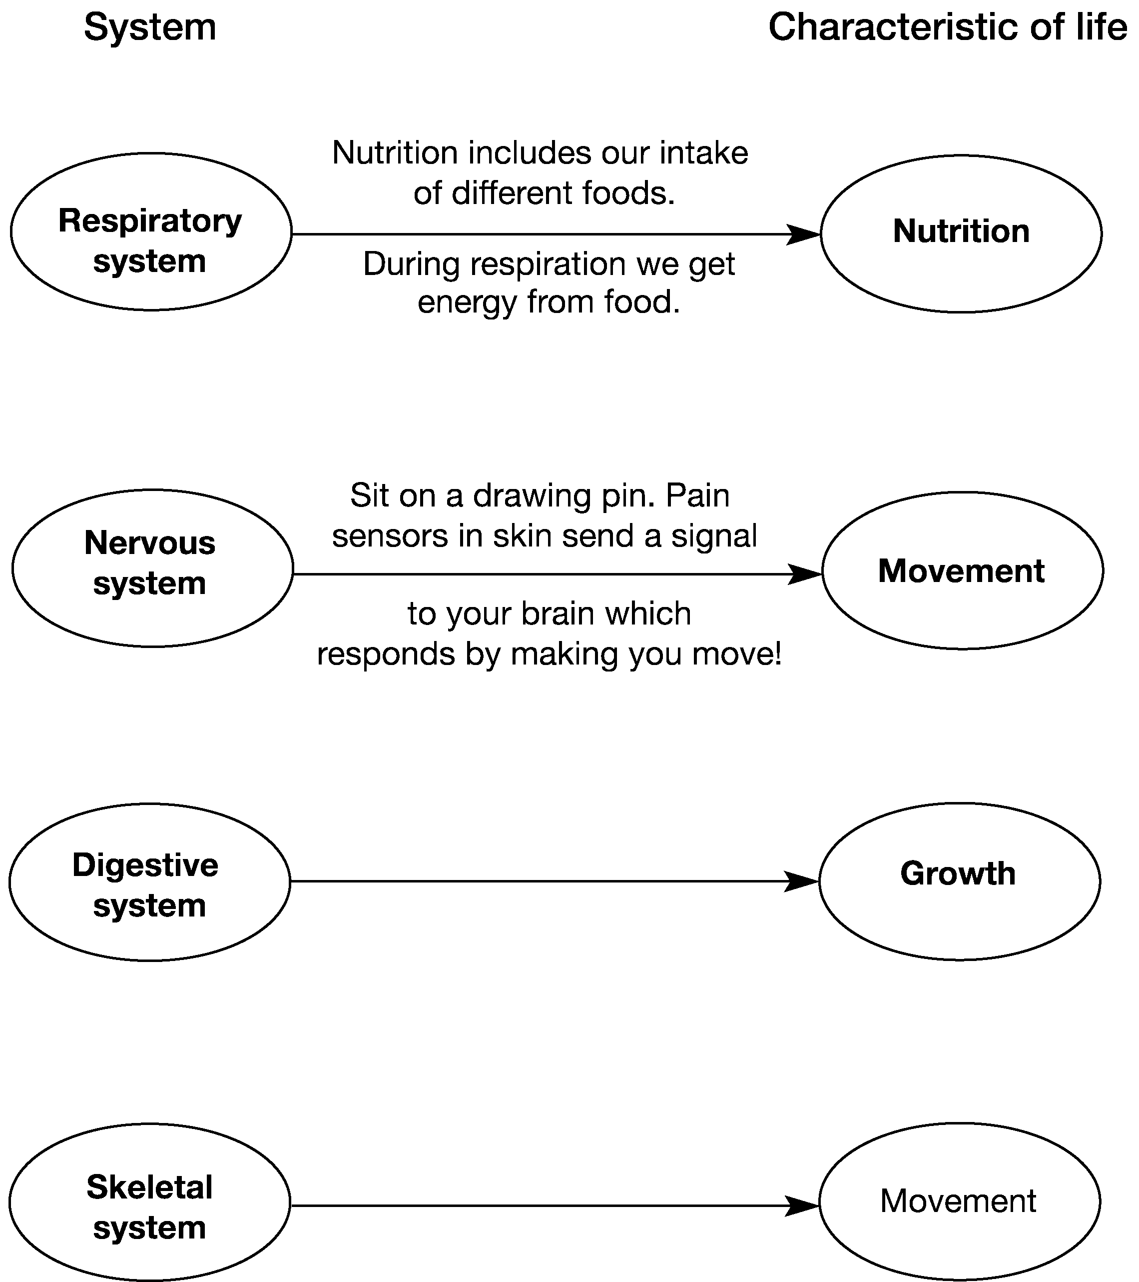

Challenge 5

FIND OUT?

Use a textbook or the internet to find out about:

STEM CELLS

What are they?

What could they be used for?

Do you think stem cell research is a good idea?

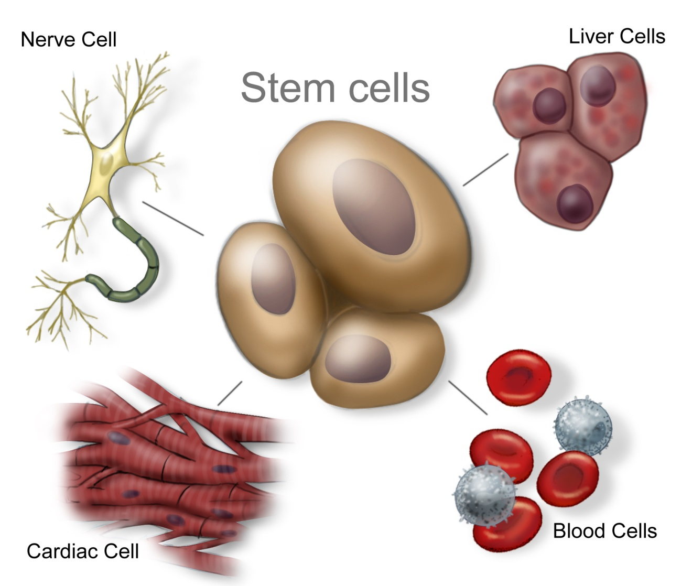

Challenge 6

TABOO

You need two players for this game.

DO NOT LET YOUR PARTNER SEE THIS SHEET.

Try to describe the following items to your partner without saying any of the “taboo” words. If they get it right, give it a tick and move on to the next one.

|  |  |  |
| --- | --- | --- |
| **heart**  taboo words:  blood, pump | **lungs**  taboo words:  air, respiration (or respiratory), oxygen, gases | **skeleton**  taboo words:  bones, support, hold, protect (or protection), organs |
| **skeletal system**  taboo words:  bones, support, protection | **circulatory system**  taboo words:  blood, heart | **brain**  taboo words:  control, important, organ |
| **artery**  taboo words:  blood, away from, back to, heart | **small intestine**  taboo words:  digestion (or digestive system), food | **carbon dioxide**  taboo words: breathe, respiration, waste product |

Now look at the following items together – if you were making this game which taboo words would you choose?

Blood

Vein

Stomach

Muscles

Challenge 7

You can draw concept maps to show connections between organs and systems. Here is an example.

**Main theme:** respiratory system

**Connect with:** energy release, respiration, chemical reaction, movement, glucose, oxygen

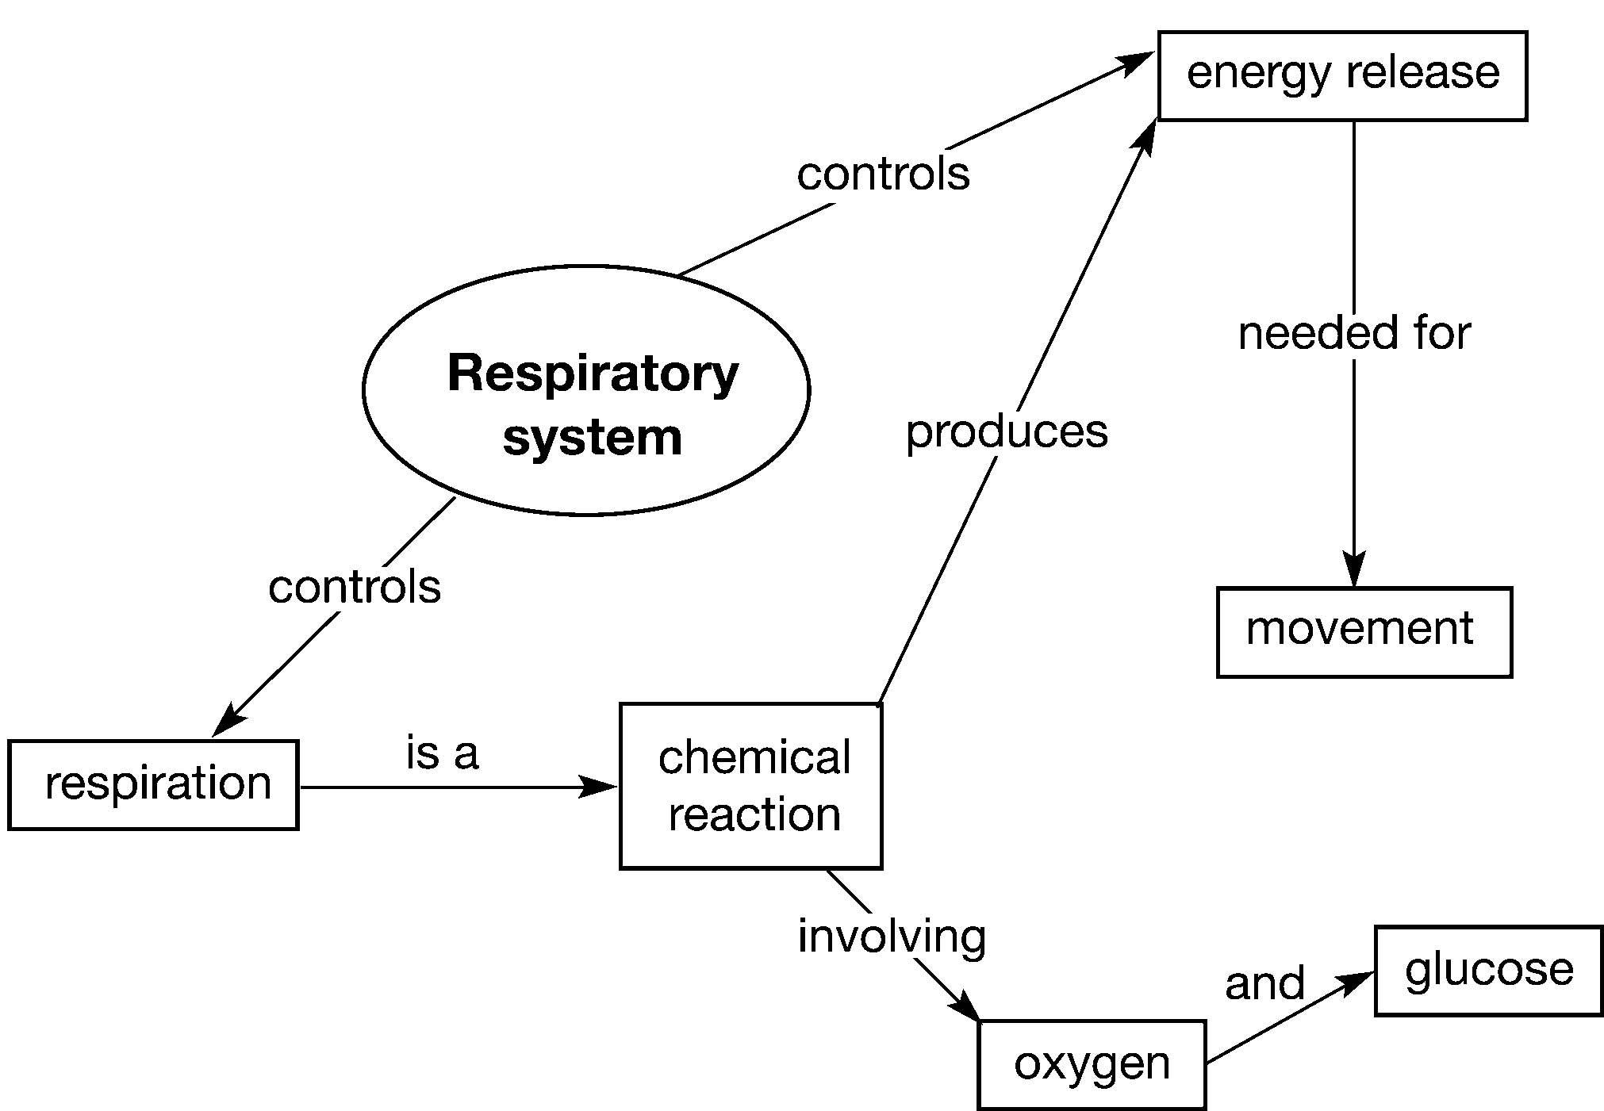

Draw a concept map using the following words. Try to add other connections and words if you can.

**Main theme:** heart

**Connect with:** blood, pump, vessel, muscle, circulatory system, skeletal system, movement, arteries, veins, oxygen, carbon dioxide

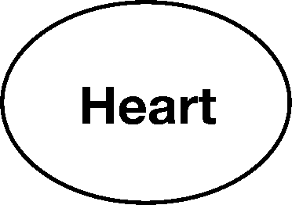

Challenge 8

WHAT IF?

We did not have a skeleton?

How might this affect our daily lives?

Would we be able to survive?

How could we solve some of the problems this could cause?

Challenge 9

Further information on plant cells

First of all, you need to know the meaning of the word, organelle.   
It sounds a little bit like organ - this gives you a clue to the meaning of the word.   
Many words in science have their origin from Latin (in fact, so do many words in English and French too).   
The Latin word “organas” means instrument – so this tells you that organelles have useful functions! Organelles are tiny structures with an important job. The nucleus and the chloroplast are both types of organelle. Without looking in your book, can you remember what they do?

Here is another diagram of a plant cell, showing a few more organelles.

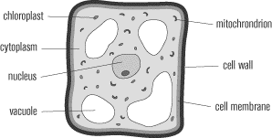

Can you remember what the different parts do? If you cover up the names, can you name all the sections in the diagram?

The only organelle you might have heard of yet is the mitochondrion. Practise saying this word – it’s pronounced “Mito-chon-dri-on”.

This is the word for one of them – if there are many, you’d call them mitochondria.

These little organelles contain lots of enzymes that are important for cell metabolism. The function of the mitochondria is respiration – converting food (glucose) into energy.

You will already know about chloroplasts. Can you remember what colour they are? The reason that they’re so important is that they are the site for photosynthesis. This means that photosynthesis happens inside the chloroplasts. If “photo” means light, and “synthesis” means making – what might you think photosynthesis meant?

**Questions**

What is the collective name for all the small structures in the cell?

Can you find out the word equations for a) respiration and b) photosynthesis (HINT use a GCSE textbook)

Write a sentence to explain to the rest of the class what photosynthesis is, and where it happens.