Challenge 1

FIND OUT?

How fire extinguishers work.

What different types are there?   
Does it matter which one you use?

Look around the lab – what fire safety precautions do you see?

Do \*you\* know what to do in the event of a fire:

At school? Or at home?

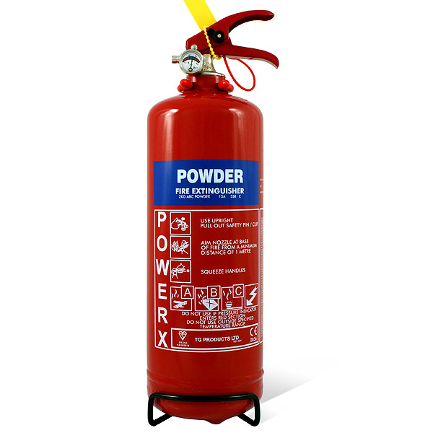

Challenge 2 WHAT IF?

What if global warming caused the ice caps to melt and the sea level rises?

Check it out on this interactive map here:

<http://ngm.nationalgeographic.com/2013/09/rising-seas/if-ice-melted-map>

What problems would this cause – for you, for your family, for your community, for the world?

What could / should be done to stop this happening?

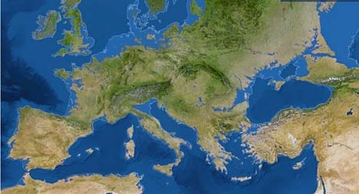

Challenge 3 Crossword

whatarereactions

Ask your teacher for a paper copy of this sheet or write the answers down in the back of your book.

Challenge 3 Crossword clues

Across

3. A change which means the products can't be returned back to the reactants.

6. Acid + \_\_\_\_\_\_\_ --> salt + hydrogen

7. Acid + alkali --> \_\_\_\_\_\_ + water

9. The \_\_\_\_\_\_\_\_ of gas given off in a chemical reaction can be measured using a measuring cylinder.

10. How you can tell that a gas is being given off.

13. Something which might change during a chemical reaction.

14. This might change during a chemical reaction.

15. A gas that can be identified by bubbling it through limewater

16. An everyday household acid

Down

1. A gas that can be identified by the squeaky pop sound given when a lit splint is put into the tube.

2. Taking an antacid for acid indigestion is an example of this type of reaction.

4. Something which can be burned.

5. pH 14 shows a solution is \_\_\_\_\_\_\_\_\_\_

8. Acid + \_\_\_\_\_\_\_\_\_ --> salt + carbon dioxide + water

11. A reaction can be described using a word \_\_\_\_\_\_\_\_\_\_.

12. A type of change like melting.

MCEN00275_0000[1]

Challenge 4

TABOO

You need two players for this game.

DO NOT LET YOUR PARTNER SEE THIS SHEET.

Try to describe the following items to your partner without saying any of the “taboo” words. If they get it right, give it a tick and move on to the next one.

|  |  |  |
| --- | --- | --- |
| Reaction  Taboo words – chemical, products, reactants | Products  Taboo words –  Reactants, reaction, chemical | Reversible  Taboo words –  Irreversible, reaction, go back |
| fuel  Taboo words – burns, fire, energy | Carbon dioxide  Taboo words – burn, breathe, gas | Global warming  Taboo words – carbon dioxide, greenhouse, temperature |
| filtering  Taboo words – paper, funnel, solution | evaporation  Taboo words – heat, water, gas | chromatography  Taboo words – pens, separating, paper |

Now, think of some more examples from this topic, including the taboo words to use with them.

E.g.

Distillation

Burning

Chemistry

What taboo words would you use?

Challenge 5

The birthplace of fireworks is generally recognised as China. It is said that a Chinese cook accidentally mixed three common kitchen ingredients: saltpetre, sulphur and charcoal and lighted it. The results were a colourful array of flames (gun powder). It was named huo yao or the chemical fire.

The first application for this, was purely for entertainment, slowly the theory took root and found that this loud sound was perfect to chase away evil spirits and to celebrate weddings, victories in battle, and religious ceremonies.

Soon the Chinese began to use fireworks in battle. The original idea of the Chinese were to scare the enemy into fleeing, the aim soon shifted from scaring the enemy to simply blowing them up.

By the 14th-15th century the idea of fireworks had spread to Europe, where there were used to celebrate great occasions. But these fireworks were still not the coloured explosions that we use today.

It was not until the 19th century that fireworks became coloured. Pyrotechnics began to use various metallic salts to make brilliant colours. The salts of these metals produce the different colours: strontium burns red: copper makes blue: barium glows green: and sodium makes yellow, magnesium, aluminium and titanium were found to give off white sparkles or a flash.

Read through and answer these questions:

1. In which country were fireworks invented?

2. What were the 3 ingredients?

3. What have fireworks been used for?

4. What is the name for firework experts?

5. What would you add to a plain firework to make a green one?



Challenge 6

FIND OUT?

About Carbon Monoxide

What is it?

How is it formed?

Why is it dangerous?

Can you find any recent news stories about the dangers?

Sketch out a poster to display in schools warning pupils of the dangers of carbon monoxide and how they can make sure their homes are safe.

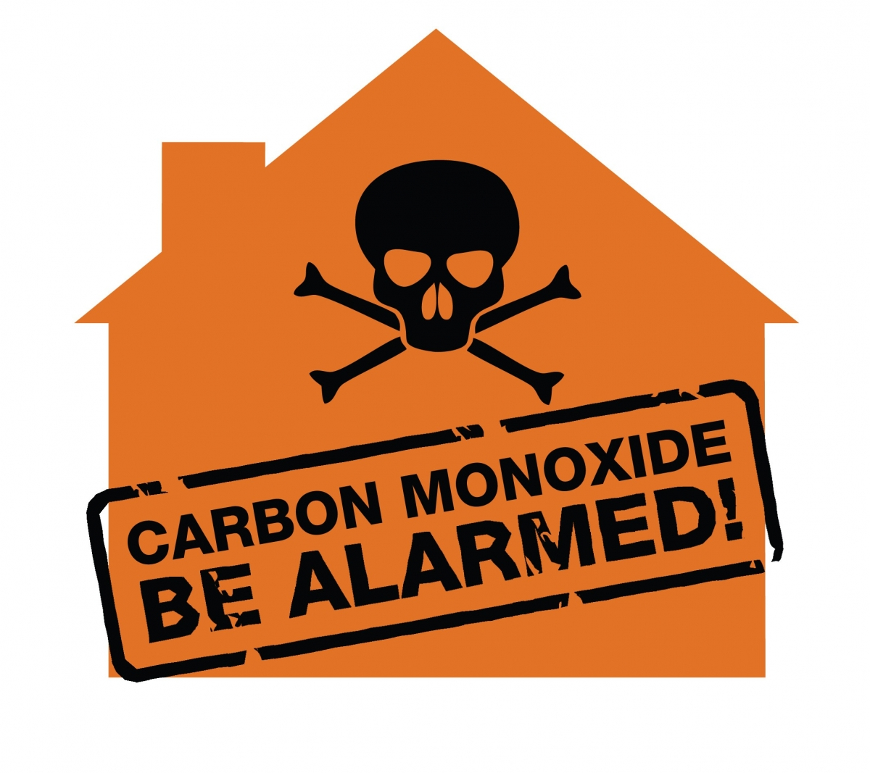

Challenge 7 – Mind map

Can you fill in the gaps on the mind map?

<http://www.tes.co.uk/teaching-resource/Reversible-and-Irreversible-Changes-Mind-Map-6309935/>

Challenge 8

Writing word equations

Chemical reactions can be represented with either words or with symbols and formulae.

They should be written as:

Reactant + reactant ===🡺 product + product

Write out the word equations described by the following:

1. A block of carbon burns in pure oxygen to give only one product, carbon dioxide gas.
2. Water is the only product from the reaction between hydrogen and oxygen.
3. Dilute hydrochloric acid reacts with magnesium solid. One of the products is a solution of magnesium chloride.

The second product is a colourless gas called hydrogen.

1. Calcium oxide is made by heating calcium carbonate. The second product is carbon dioxide gas.
2. Calcium carbonate gives carbon dioxide, calcium sulphate, and water when added to a beaker containing dilute sulphuric acid.
3. Liquid magnesium oxide can be broken up by electricity into magnesium and oxygen.
4. When sodium is added to water to it floats on the surface and fizzes. The hydrogen gas made is explosive. The sodium also turns the water into an alkali called sodium hydroxide.
5. If magnesium is added to copper sulphate solution, the products are copper metal and magnesium sulphate solution.