Challenge 1
FIND OUT?
Use a textbook or the internet to find out about:
CARL LINNAEUS
Who was he?
When did he live?
What did he do?
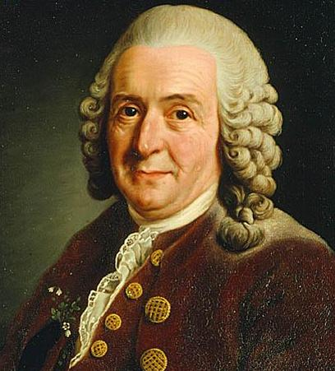

Challenge 2
Minibeast top trumps
You need to work in a pair for this challenge – ask your teacher for the cards.
https://www.tes.com/teaching-resource/minibeast-trump-cards-6123525
When you have played, work together to design another card of your own, featuring a “minibeast” that has not already got a card.

Then – discuss what the term “minibeasts” means. Is this a scientific way to describe the animals on the cards?

Challenge 3 WHAT IF?

What happens if we actually do find aliens? And what if we don't?
People are desperately looking for life throughout the Universe, from our neighbouring planet Mars, to Saturn’s moons, and to exoplanets, planets outside of our solar system. Spacecraft are looking at all these different planets, looking at the planets' environments, and doing complex analysis of exoplanet atmospheres, looking for any clues that life may be hidden there. If you ask people on the streets, finding aliens means finding little green men or Star Trek like aliens. Astrobiologists are not as picky as that, they hope to find any indication of life, be it microscopic fossilised cells, or atmospheres similar to that here on Earth which could hint that life could survive there. Altogether, there are four possible scenarios of finding extraterrestrial life, according to Dr Lewis Dartnell
- Detecting long-extinct fossilised life nearby for example on Mars, which will not teach us much about the life-form.
- Detecting life nearby for example in the oceans of Enceladus, one of the moons of Jupiter.
- Detecting life far away, on an exoplanet for instance.
- And finally, a deliberate attempt at contact (“on Twitter”, Dr. Dartnell jokes), which we humans then will have to decode.
Of course, any of these would create huge excitement, not only in the scientific world but for everyone.
But what will happen if all the research leaves us empty handed? Could we be truly alone in the Universe? Dr David Waltham, University of London, asks this question and believes the answer is ‘yes, we are indeed alone’. The Earth is simply too special, having enjoyed too unique and specific conditions to hope for another planet to be similar.
The Earth has had four billion years of extremely good weather, a fact many Brits might have a hard time accepting. But when you look at what would have happened, had the Earth been spinning at a slightly different speed or orbiting slightly differently around the Sun, our planet would either have been stuck in an intense ice age or would have had a wildly unstable climate. Both of these extreme weather conditions would have made life as we know it today impossible.
The fact that the Earth happened to come into exactly the optimal conditions was very, very lucky and such an event will not happen very often elsewhere. Dr Waltham calculates that the possibility of such an event happening elsewhere is about one in one hundred billion billion. Failing to find extraterrestrial life is therefore a very real possibility. One way or another, it is possible that we are not alone, but the chance of finding life are pretty small, let alone something we could have a conversation with. So we probably should not hold our breath for an alien tweet any time soon.
What do you think?
Are we alone in the universe?
How would you react if there was an “alien tweet”?

Challenge 4 SUNDEWS
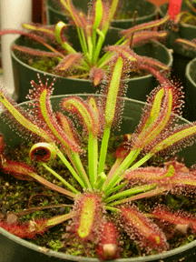
Sam was looking at different living things during a classification lesson. He found the SUNDEW more difficult to classify so he found out this information.

Sundews grow in areas where the soil has few minerals. The root system is small and the leaves are arranged around the stem in a rosette (daisy plants have a similar arrangement of leaves). The leaf cells contain chloroplasts which make the leaves green. It is hard to see the green colour because they have hairs on their leaves which make the leaves look red. The hairs produce large drops of sticky glue. Insects are attracted to the sundew and become stuck on the leaves. The leaves can fold around the insect and release enzymes which digest the insect. The sundew absorbs the minerals from the insect. This is why it can be called carnivorous. In autumn, they produce seeds from their small white flowers.
He decided to classify the SUNDEW as a flowering plant.

- What evidence does Sam have to classify the Sundew as a flowering plant?
- UNDERLINE all the words which are names of plant organs.

- All living things show 7 characteristics of life (MRS GREN)
How does the Sundew show each of these characteristics?

Challenge 5 Binomial Classification
Using whatever resources you have available try and find out the English names for the following organisms.......
Latin Name | English Name
Bufo bufo
Panthera tigris
Quercus robur
Agaricus bisporus
Fragaria vesca
Balaenoptera musculus
Equus caballus

and the Latin names given to the following organisms:
English Name | Latin Name
Fox
Dandelion
Cod
Cockroach
Wren
Edible Crab
Rye grass

Why is Latin used?
What are the advantages and disadvantages of using Latin?
Do you recognize any of the words used?
Find out some more interesting Latin names!
Challenge 6
TABOO
You need two players for this game.
DO NOT LET YOUR PARTNER SEE THIS SHEET.
Try to describe the following items to your partner without saying any of the “taboo” words. If they get it right, give it a tick and move on to the next one.
Frog  Taboo words – amphibian, tadpole, pond | Fish  Taboo words –  Vertebrate, fins, sea | Reptile  Taboo words –  Vertebrate, snake, lizard
mammal  Taboo words – vertebrate, hair, milk | bird  Taboo words – feathers, fly, beak | amphibian  Taboo words – frog, toad, tadpole
vertebrate  Taboo words – back, bone, spine, invertebrate | classification  Taboo words – group, categories | plant  Taboo words – green, chlorophyll, photosynthesis

Now, think of some more examples from this topic, including the taboo words to use with them.
Challenge 7
Making a Key
Ask your teacher for a page of pictures.
Make a key to identify all the living things on that page.

http://www.tes.co.uk/ResourceDetail.aspx?storyCode=6111847
Challenge 8
Duck-billed Platypus (Ornithorhynchus anatinus)
Study the diagram below then answer questions 1 – 7.
The Duck-billed Platypus is a primitive Australian mammal that lays eggs. When an egg hatches, the tiny baby (called a puggle) drinks its mother's milk, which comes from tiny openings in the mother's belly. Duck-billed platypuses live for 10-17 years. Platypuses live in burrows and spend much of their time in freshwater ponds and streams.
Anatomy: The Duck-billed Platypus is about the size of a pet cat. They have thick, waterproof fur all over their bodies except for the feet and bill which are hairless. The legs sprawl out to the side of the body, giving it a lizard-like walk. The males are venomous (have a poisoned spike on their ankles which the platypus can use to kill small animals in self-defence).
Diet: This carnivore (meat-eater) uses its bill to strain its tiny prey, like crayfish, worms, insects, snails, and shrimp from muddy water. It can store food in cheek pouches while it is hunting underwater.
1. What does a platypus produce that no other mammal does?
2. What is the name given to a baby platypus?
3. Why do the males have a poisonous spike on their ankles?
4. What feature does a platypus have that you may find on a bird?
5. What features does a platypus have that you would expect mammals to have?
6. What is a carnivore?
7. Why might some people find it difficult to sort a platypus into one individual group? In which other groups might a platypus be placed and why?

