Challenge 1
FIND OUT?
Use a textbook or the internet to find out about:
John Dalton
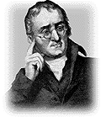
Who was he?
When did he live?
What did he discover?

Challenge 2
WHAT IF?

Supermarkets organised their products into solids / liquids / gases

How would you organise a supermarket in this way? Which products would be in each aisle?
What sort of things would you find in the gas aisle?
Where would eggs go?
What problems would this cause?
What advantages would this give?

Challenge 3
Page 39 of this document: http://www.education.leeds.ac.uk/assets/files/research/cssme/ns-tu/explaining_change_processes.pdf
Challenge 4
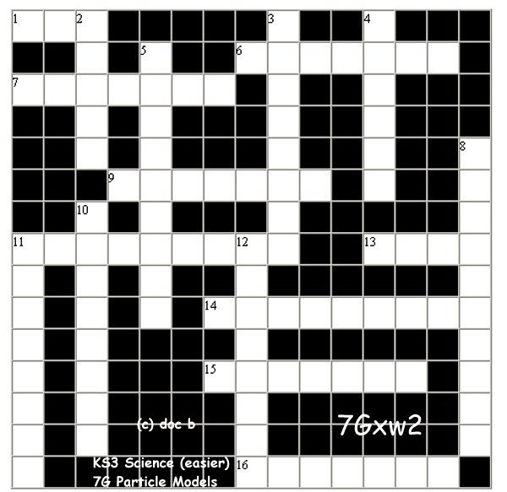
Across:  1 The particles are far apart and moving fast. (3)  6 When a liquid changes to a gas fast for a cup of tea! (7)  7 Ice thawing is an example. (7)  9 The partices in a liquid are all ? up! (7)  11 The 'bits' of solids, liquids and gases. (9)  13 One way in which solids are different than gases or liquids. Its an easy question really, its not ? (4)  14 The particles of a solid are under going this without causing a sound! and more so on heating! (9)  15 The 'pattern' of particles in a solid is very ? (7)  16 What a solid does on heating (without melting) as the atoms get more excited! (7) | Down:  2 The particles are closest together in this state. (5)  3 Very difficult to do with a solid, not much spare space! (8)  4 The particles are close together but they can still move around quite freely in this state. (6)  5 A word that means particles spreading in liquids and gases because of their random movement. (9)  8 This is happening to a gas when it is cooled to form a liquid. (10)  10 When a liquid changes to a solid it is ? (8)  11 This is caused by gas particles hitting the side of a container millions of times a second! (8)  12 You must obtain this to check out a theory in a scientific court! (8)

Challenge 5
FIND OUT?
Use a textbook or the internet to find out about:
The Large Hadron Collider
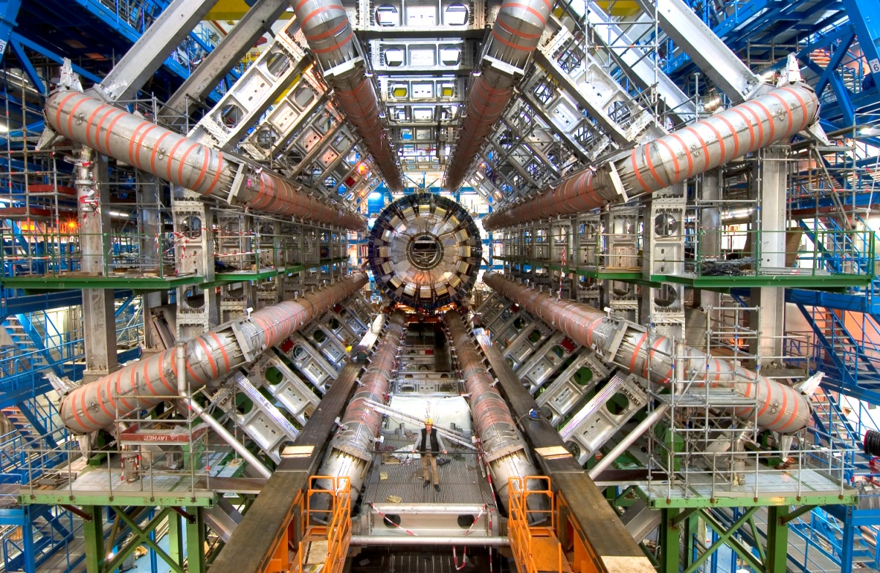
What is it?
Where is it?
How long is it?
What is it for?

Challenge 6
TABOO
You need two players for this game.
DO NOT LET YOUR PARTNER SEE THIS SHEET.
Try to describe the following items to your partner without saying any of the “taboo” words. If they get it right, give it a tick and move on to the next one.
Solid  Taboo words – liquid, gas, particles, joined | Liquid  Taboo words – solid, gas, flows | Gas  Taboo words – liquid, solid, far apart, squash
Condense  Taboo words – gas, liquid, water, change | Evaporate  Taboo words – heat, liquid, gas, change | Freeze  Taboo words – ice, change, cold, solid

Now look at the following items together – if you were making this game which taboo words would you choose?
Melt
Particles
Solution
Diffusion

Challenge 7
States of matter and temperature
Look at this table of boiling points and melting points of different
substances:

Substance | Boiling point (^{º}C) | Melting point (^{º}C)
water | 100 | 0
chlorine | –34 | –101
bromine | 58 | –7.3
mercury | 357 | –39
ethanol | 78 | –114

To do
Create a temperature scale to plot these temperatures onto.
- Think about how big your range will have to be. What is the
highest temperature? What is the lowest temperature?
- Work out what the smallest divisions on the scale should be.
- Mark the boiling points and melting points for the different
substances.
To answer
- Room temperature is about 20ºC. What state is chlorine in
at room temperature?
- At 30ºC what state is bromine in?
- Above what temperature is water a gas?
- What state is ethanol in at 55ºC?
- At –8ºC what state is bromine in?

Challenge 8
Four students were having a discussion about ketchup, they decided it was a liquid.
They each came up with an explanation.
Rank the explanations 1 to 4, where 1 is the best explanation and 4 is the worst.
Explain why you came to your decisions.

Name | Explanation | Ranking  (1–4) | Reasoning
Joe | Ketchup is a liquid because if you leave the bottle to sit for a while it all gathers at the bottom.
Lucy | The tomato ketchup is a liquid.
Henry | The tomato ketchup cannot be a solid because you can’t pick it up in one piece except when it is dried on around the cap, then it is a solid.
Fred | Tomato ketchup is a liquid because when you pour it onto your plate it spreads out and only stops when it reaches the edge. It is definitely not a gas because I can see it and it doesn’t fly off into the air.
Can you write your own explanation?

