Challenge 1

FIND OUT?

Who was the first baby born by IVF?

Find some news articles about her birth and then see if you can find out more about her life.

How old is she now and how has being the first IVF baby affected her?

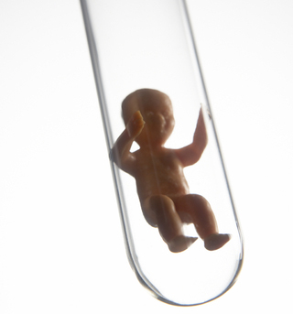

Challenge 2

FIND OUT?

What is cloning?

Does it happen naturally?

Which plants and animals have been cloned by humans?

Who is in the picture below?

If it were possible to clone humans, do you think we should do this?

Why or why not?

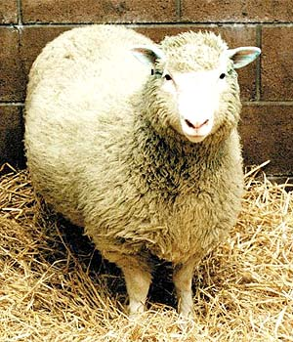

Challenge 3

**7B Reproduction Crossword**



**Challenge 5 – reproduction crossword clues Across**

**3** Organ in females in which a baby develops. (6)

**5** A mixture of sperm cells and special fluids released by men during sexual intercourse. (5)

**6** Fusing of a male sex cell with a female sex cell. (13)

**8** Carries egg cells from the ovaries to the uterus in women. (7)

**9** The male sex cell. (5,4)

**10** When the penis becomes stiff. (8)

**12** A cell used for sexual reproduction. (3,4)

**15** When a woman has an embryo growing inside her uterus. (8)

**19** Female reproductive organ which produces egg cells. (5)

**20** Semen is pumped out of a man's penis during sexual intercourse. (11)

**21** Time when physical changes happen in the body between the ages of about 11 and 15. (7)

**23** Tiny new human life which grows by cell division from a fertilised egg cell. (6)

**24** Monthly discharge blood and other material from the lining of the uterus (12)

**Down**

**1** All the reproductive organs. (12,6)

**2** Releasing of an egg cell from an ovary in women. (9)

**4** Producing new organisms by the joining of two sex cells. (6,12)

**7** Male reproductive organ, produces sperm cells. (6)

**11** A tube carrying semen or urine running down the centre of the penis in males (7)

**13** The female sex cell. (3,4)

**14** Bag of skin containing the testes in males. (7)

**15** Organ which takes oxygen and food out of the mother's blood and puts waste materials into the mother's blood. (8)

**16** When the placenta is pushed out through the vagina. (5, 5)

**17** Tube in females where the penis is placed during sexual intercourse. (6)

**18** When the ovaries in women stop releasing eggs. (9)

**22** Name given to the developing embryo. (5)

Challenge 4

**If I am the Answer, what is the Question?**

|  |
| --- |
| Fertilisation |
| Ovulation |
| Ovum |
| Sperm |
| Zygote |
| Implantation |
| Fertilization |
| Ejaculation |
| Uterus |
| Cell division |
| Identical twins |
| Conjoined twins |
| Fraternal twins |

Challenge 5

TABOO

You need two players for this game.

DO NOT LET YOUR PARTNER SEE THIS SHEET.

Try to describe the following items to your partner without saying any of the “taboo” words. If they get it right, give it a tick and move on to the next one.

|  |  |  |
| --- | --- | --- |
| **sperm**  taboo words:  swim, tail, male | **ovary**  taboo words:  eggs, female, reproduction | **uterus**  taboo words:  womb, baby, female |
| **Menstrual cycle**  taboo words:  female, 28 days, period | **ovulation**  taboo words:  ovary, egg, day 14 | **placenta**  taboo words:  baby, belly button, cord |
| **puberty**  taboo words:  boy, girl, maturity | **fertilisation**  taboo words:  sperm, egg, joining |  |

Now look at the following items together – if you were making this game which taboo words would you choose?

Egg

Amniotic fluid

pregnancy

Challenge 6

|  |  |  |  |  |  |  |  |  |  |  |  |
| --- | --- | --- | --- | --- | --- | --- | --- | --- | --- | --- | --- |
|  |  |  |  |  |  |  |  |  |  |  |  |
|  |  |  |  |  |  |  |  |  |  |  |  |
|  |  |  |  |  |  |  |  |  |  |  |  |
|  |  |  |  |  |  |  |  |  |  |  |  |
|  |  |  |  |  |  |  |  |  |  |  |  |
|  |  |  |  |  |  |  |  |  |  |  |  |
|  |  |  |  |  |  |  |  |  |  |  |  |
|  |  |  |  |  |  |  |  |  |  |  |  |
|  |  |  |  |  |  |  |  |  |  |  |  |
|  |  |  |  |  |  |  |  |  |  |  |  |
|  |  |  |  |  |  |  |  |  |  |  |  |
|  |  |  |  |  |  |  |  |  |  |  |  |

|  |  |  |
| --- | --- | --- |
| animals  birth  cervix  clones  embryo  female  fertilisation  foetus | hormone  pregnant  semen  sperm  testes  umbilical  uterus | womb  menstrual  organ  oviduct  ovulation  penis  placenta |

Your tasks:

1. (The easy bit) Use the blank square to produce a word search that uses as

many words as possible from the list below.

2. (The tricky bit) Write a clue for each word that you have used.

Challenge 7 Do you think it is right for parents to choose the sex of their baby?

This is now possible, due to new techniques, but is currently not allowed except under very rare circumstances.

What would happen if all families were allowed to choose the sex of their babies?  
Would *you* do this?  
What problems could this cause in society?  
What could the “rare circumstances” be that allow parents to choose?

What about the following situations? Should these parents be allowed to choose?





