Challenge 1

FIND OUT?

Use a textbook or the internet to find out about:

ROSALIND FRANKLIN

Who was she?

What did she do?

She was not given full recognition for her work at the time. Why do you think this was? What do you think could be done now to acknowledge her contribution?

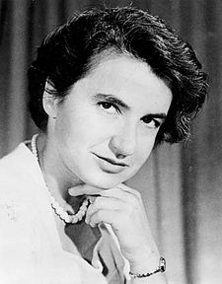

Challenge 2

WHAT IF?

We could clone humans?

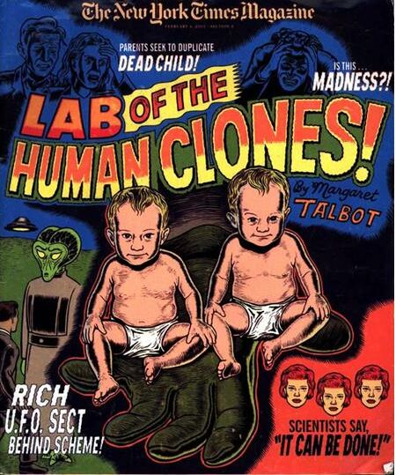

What is cloning?

Would cloning humans be a good idea?

What problems could it cause?

Challenge 3

WHAT IF?

If identical twin brothers married identical twin sisters, would all their children look the same?

Who do you agree with and why?



Challenge 4

TABOO

You need two players for this game.

DO NOT LET YOUR PARTNER SEE THIS SHEET.

Try to describe the following items to your partner without saying any of the “taboo” words. If they get it right, give it a tick and move on to the next one.

|  |  |  |
| --- | --- | --- |
| Genes  Taboo words – nucleus, chromosomes | Chromosomes  Taboo words –  Cell, nucleus, genes | Extinction  Taboo words –  Dodo, dinosaurs, dead |
| Nucleus  Taboo words – cells, controls | Identical  Taboo words – twins, same | Inherited  Taboo words – parents, offspring, environment |
| DNA  Taboo words – genes, cell, nucleus | Franklin  Taboo words – DNA, house, Rosalind | Variation  Taboo words – differences, genes, environment |

Now, think of some more examples from this topic, including the taboo words to use with them.

Challenge 5 **DNA: Cracking the Code**

A gene is like a long sentence which gives instructions on how to make part of a person. Each sentence consists of lots of three letter ‘words’. These words are written in a code, using only the letters A, T, C and G (abbreviations for the bases Adenine, Thymine, Cytosine and Guanine).

Each word is called a **codon**, and codes for a piece of protein called an **amino acid**. These amino acid join together in a chain to form a **protein**, which determines something about you – for example your hair colour.

The Genetic Code for Amino Acids

|  |  |  |  |  |  |  |  |
| --- | --- | --- | --- | --- | --- | --- | --- |
| TTT | Phe | TCT | Ser | TAT | Tyr | TGT | Cys |
| TTC | TCC | TAC | TGC |
| TTA | Leu | TCA | TAA | Stop | TGA | Stop |
| TTG | TCG | TAG | TGG | Trp |
| CTT | Leu | CCT | Pro | CAT | His | CGT | Arg |
| CTC | CCC | CAC | CGC |
| CTA | CCA | CAA | Gln | CGA |
| CTG | CCG | CAG | CGG |
| ATT | Ile | ACT | Thr | AAT | Asn | AGT | Ser |
| ATC | ACC | AAC | AGC |
| ATA | ACA | AAA | Lys | AGA | Arg |
| ATG | Met | ACG | AAG | AGG |
| GTT | Val | GCT | Ala | GAT | Asp | GGT | Gly |
| GTC | GCC | GAC | GGC |
| GTA | GCA | GAA | Glu | GGA |
| GTG | GCG | GAG | GGG |

The three letter abbreviations (Phe, Leu, etc) are the names of the amino acids.

A protein is made up of a chain of amino acids

Here are the proteins that determine hair colour:

Met-Ser-Thr-Gln-Phe = Red hair

Met- Ser-Thr-His-Leu = Blonde hair

Met-Pro-Thr-His-Phe = Black hair

Met-Pro-Thr-Gln-Leu = Brown hair

Using the decoder above, find out what colour hair each of these boys will have, according to their hair colour gene. (Hint: separate each codon with a dash eg. TAG/GAT/CCA…)

|  |  |  |  |
| --- | --- | --- | --- |
|  | http://www.clker.com/cliparts/b/j/y/Y/N/z/boy-black-white-md.png | http://www.clker.com/cliparts/E/J/M/G/y/O/boy-face-black-white-md.png | Boy Face Outline Clip Art |
| DNA | ATGTCAACTCATCTCTAA | ATGCCAACTCATTTCTAG | ATGTCAACTCAATTCTAG |
| Protein |  |  |  |
| Hair colour |  |  |  |

Challenge 6

FIND OUT?

Use a textbook or the internet to find out about:

STEM CELLS

What are they?

What could they be used for?

Do you think stem cell research is a good idea?

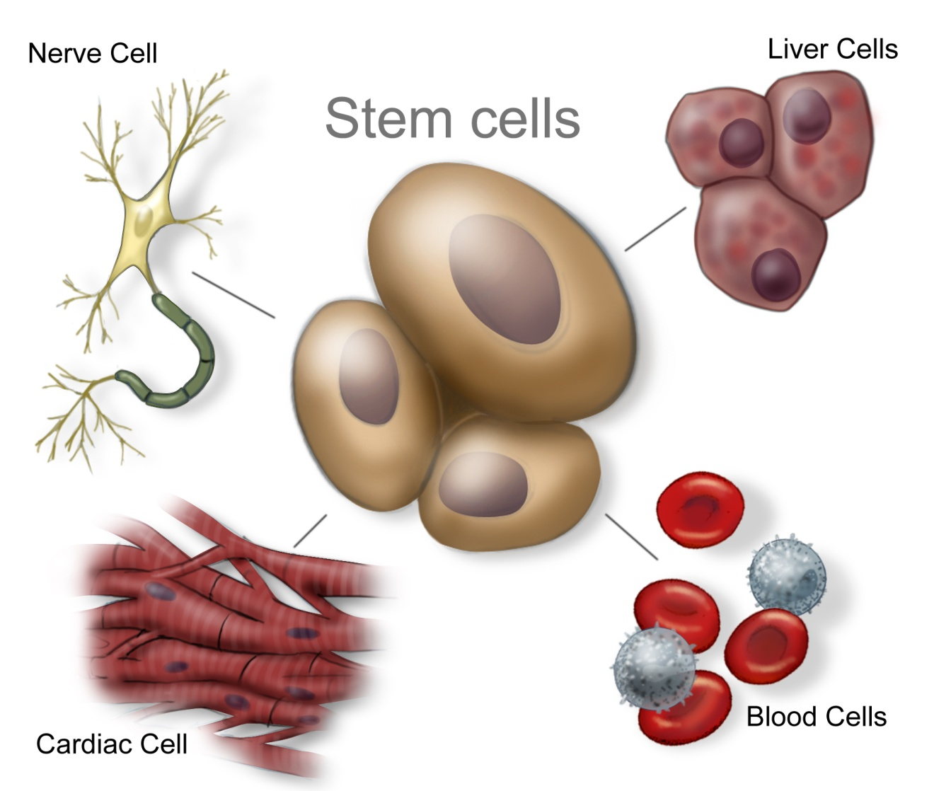

Challenge 7

Read the article below

**Food doesn’t taste the same to everyone. Genetic variation between people means that it’s easier for some of us than others to eat our greens.**

Some people have lots of taste buds on the tongue and experience most

tastes more intensely. There are also differences in individual taste receptors.

The best known is a genetic variation in a receptor that registers bitterness:

people with two copies of a variant in the receptor gene find certain chemicals

unbearable, including the man-made sulphur-containing compound

phenylthiocarbamide (PTC).

Those with two copies of the insensitive variant

usually cannot taste them at all, and one of each leaves you somewhere in

between. The variance was discovered in the 1930s, but the gene involved

was only identified in 2003.

PTC evokes similar responses to the sulphur-containing compounds in some

vegetables, such as broccoli, cabbage and Brussels sprouts.

Children are more sensitive to unpleasant tastes; this may have given them

better protection against the toxins found in some wild plants. In some

children, extra sensitivity to bitterness (often resulting in a dislike of Brussels

sprouts) goes with a strong liking for sugary foods and drinks, possibly

because sweetness can overwhelm traces of bitterness.

Can you write a definition for the following words:

1. Variation
2. Receptor
3. Variant
4. Gene

Write a sentence to explain to a parent why their child may refuse to eat broccoli!

Challenge 8 Genetic testing

What’s the issue?

Do your genes hold secrets that could change the way you live your life?  
Scientists are developing a range of tests which could tell you your risk of developing genetic conditions from Huntington’s disease to cancer.   
But under what circumstances would you want to know?   
Tests for rare genetic conditions such as cystic fibrosis or Huntington’s disease have been available for many years. You might want to know the chance of passing on these genes to your children.

Now scientists are getting a better understanding of how small variations in people’s genes affect their health. One day, genetic tests may allow us to predict the chance of someone developing almost any disease.

How do genetic tests work?

A small blood sample or a few cheek cells are collected with a brush or cotton swab. The sample is then sent to a lab which tests for specific genetic conditions. The results are finally reported back to the person’s doctor, who is able to explain the results and provide medical and psychological support if necessary.

What’s the difference between single-gene conditions and multifactorial conditions?

Single-gene conditions are caused by mutations in just one gene. They usually have a clear pattern of genetic inheritance, which makes them easy to diagnose with a genetic test.

In contrast, a genetic test can only reveal a statistical likelihood of developing a multifactorial condition. Examples of multifactorial conditions include diabetes, asthma and high blood pressure, which are all caused by a combination of different genetic variations and environmental and lifestyle factors. They often run in families and are much more common than single-gene conditions, but don’t have a clear pattern of genetic inheritance. This makes precise diagnosis and predictions of likelihood difficult.

■ What are the potential impacts of having a test?

■ Who else might be affected by your decision to have a genetic test? Your siblings? Your own children or parents?

■ Who should have access to your test results? Only you? Your doctor? Your school? Your employer?

■ Should everyone be tested for genetic conditions? Do you think you could cope with the results?

■ Should parents and carers be allowed to have their children tested?

Challenge 9



Challenge 10 **Crossword  
Ask your teacher for a copy of the grid to fill in. Clues are below:**

**Across**

**3** When different varieties or breeds are mated with one another. (5,8)

**6** Grows into a new plant. Made by conifers and flowering plants. (4)

**8** A length of DNA that controls one inherited characteristic of an organism. (4)

**10** Something that is not affected by disease is said to be resistant to it. (9)

**12** How much of something useful to humans that an organism produces. (5)

**14** The differences between things or organisms. (9)

**16** Passed on to an organism from its parents. (9)

**17** The instructions that control your characteristics. These instructions are found on genes. (7,11)

**18** A group of organisms that can reproduce with each other to produce offspring that will also be able to reproduce. (7)

**19** The features of an organism. (15)

**20** Scientific word for sex cell. (6)

**Down**

**1** The male sex cell (gamete) in plants. (6)

**2** Fusing of a male sex cell with a female sex cell. (13)

**4** A set of animals that are in some way different from other members of the same species. (5)

**5** Part of the female reproductive organs where egg cells are loacted. (5)

**6** When humans choose certain animals and plants that have useful characteristics and breed more of these organisms. (9,8)

**7** A large molecule that contains genes. (3)

**9** Transfer of pollen from an anther to a stigma. (11)

**11** The surroundings of an organism. (11)

**13** A set of plants that are in some way different from other members of the same species. (7)

**15** Part of the female reproductive organs in a plant. It is where pollen lands. (6)

**Challenge 10 crossword grid**

